國立中正大學 前瞻製造系統碩士學位學程
國立中正大學
前瞻製造系統碩士學位學程
碩士論文

碩士論文 使用波段選擇和高光譜成像評估光譜輔助視覺增強器（SAVE）在皮膚癌檢測中的功效

使用波段選擇和高光譜成像評估光譜輔助視覺增強器（SAVE）在皮膚癌檢測中的功效

指導教授：王祥辰
姓名：嘉孺
學號：611445005
系所：前瞻製造系統碩士學位學程

姓名：嘉孺

中華民國 113 年 07 月 24 日
Master of Science in Advanced Manufacturing Systems
Master of Science in Advanced Manufacturing Systems
National Chung Cheng University
National Chung Cheng University
Master Thesis

Assessing the Efficacy of Spectrum Aided Visual Enhancer (SAVE) in Skin Cancer Detection using Band Selection and Hyperspectral Imaging
Assessing the Efficacy of Spectrum Aided Visual Enhancer (SAVE) in Skin Cancer Detection using Band Selection and Hyperspectral Imaging”

Nampelly Kalpana

Advisor: Prof. Hsiang-Chen Wang, Ph. D.

By Kalpana 2024
July, 2024

Acknowledgments
Whether big or small, the success of every endeavor becomes a reality through passionate dedication and hard work. I would like to take this moment to thank all who helped and supported me. To my research supervisor, Dr. Hsiang-Chen Wang, Ph.D., Professor, Department of Mechanical Engineering, I feel the deepest views of gratitude for his allowing me to do research and all the very valuable recommendations in the process of research about skin cancer detection from dermoscopic images, and spectrum-aided visual enhancer technique used in this study.
I am also indebted to all the instructors, lecturers, and many staff members; not to forget my friends who were a big help in my studies. I would like to express my gratitude to my lab collaborators for their continuous encouragement and gentle humor in the laboratory. I feel so lucky to have encountered such fine individuals as friends. After all, I got some great memoirs for the AIM-HI Master's program. I am also highly indebted to my family and well-wishers who have been very supportive during my rough times.
I would also like to use this opportunity to thank National Chung Cheng University for the resources made available to accomplish my master's thesis. Finally, I am extremely obliged to Aravind from National Chung Cheng University for his commands have earned my very sincere gratitude.

摘要
皮膚癌中的黑色素瘤是由人體內畸形細胞的無阻礙發育而產生的，而目前有許多研究是用來診斷皮膚癌病變的良性與惡性。而本研究的主要目的，是利用高光譜轉換窄頻技術（Spectrum-Aided Vision Enhancer，SAVE）結合深度學習的方法，幫助皮膚科醫師準確地診斷早期皮膚癌。SAVE影像技術無需使用實際的窄頻鏡即可將白光影像（WLI）轉換為 SAVE。
此資料集是由大林慈濟總醫院腫瘤科和ISIC庫提供，我們利用兩個不同的資料集（SAVE和WLI）來訓練模型，其中包含878張白光影像和878張高光譜轉換窄頻影像，接著將皮膚癌影像分類成：肢端雀斑黑色素瘤（ALM）、結節性黑色素瘤（NM）、淺層擴散性黑色素瘤（SSM）和原位黑色素瘤（M in Situ）。
資料集被分為60%的訓練集、20%的驗證集和10%的測試集，並使用You Only Look Once（YOLO）框架改編版 v5、v8、v9、YOLO-NAS 和 Roboflow 3.0模型來預測和分類黑色素瘤。根據產生的混淆矩陣和評估指標（Precision、Recall、Sensitivity、Specificity、Accuracy 和 F1-score）來判斷演示的執行結果。
經由各模型訓練後，結果顯示SAVE 訓練模型的整體評估指標比 WLI 好。SAVE訓練模型的平均精確度於YOLOv5、YOLOv8、YOLOv9、YOLO-NAS和Roboflow 3.0分別為0.919%、0.946%、0.849%、0.69%和0.68%。而WLI訓練模型的平均精確度於YOLOv5、YOLOv8、YOLOv9、YOLO-NAS和Roboflow 3.0分別為0.86%、0.938%、0.80%、0.733% 和 0.719%。與其他模型相比，具有訓練SAVE資料集的YOLOv8模型表現出更高的評估分數，而訓練SAVE資料集的YOLOv5模型擁有最高的F1-score（0.81%）。以本研究結果來看，SAVE資料集的訓練結果表現出更高的準確率，而結合YOLO模型更顯著提高了檢測能力。
關鍵字：皮膚癌、黑色素瘤檢測、高光譜成像、SAVE、窄頻影像、白光影像、YOLOv5、YOLOv8、YOLOv9、YOLO-NAS、ROBOFLOW 3.0

Abstract
Nowadays, skin cancer, eminently melanoma, develops from the unimpeded development of malformed cells in the human body. Many researches show that a lot of research is being done to determine whether a skin lesion is benign or malignant. The main purpose of this research is to study the skin lesion from the images using a deep learning model. SAVE and a deep-learning-based method has been suggested to help dermatologists with the early and accurate diagnosis of skin cancers.
The dataset is collected from the Buddhist Dalin Tzu Chi General Hospital, Oncology Department, Dalin and the ISIC library. This research used two diverse datasets, specifically SAVE and WLI, to train the model. The dataset has 878 white light images and 878 spectrum-aided visual enhancer images. The SAVE images were generated by using a save conversion method. This algorithm can transform a WLI image into SAVE without using a spectrometer or spectral head. They were separated into 60% training, 20% validation, and 10% test sets to train the model. The main aim of the study to classify skin cancer is based on Acral lentiginous melanoma (ALM), Nodular melanoma (NM), Superficial Spreading Melanoma (SSM), and Melanoma in Situ (M in Situ). The dataset was split into test, train, and valid sets to train the model. This study used the You Only Look Once (YOLO) framework adaptations 5, 8, 9, Yolo-NAS, and Roboflow3.0 models to predict and classify melanoma. The demonstrated execution results were judged according to the generated confusion matrix and indicating parameters, like Precision, Recall, Sensitivity, Specificity, accuracy and F1-score. The test investigation shows that the SAVE dataset has way better execution than WLI. By utilizing the SAVE dataset, the average precision is 0.919%, 0.946%, 0.849%, 0.69%, and 0.68% separately for Yolov5, Yolov8, Yolov9, Yolo-Nas, and Roboflow3.0 on a dataset of 878 pictures. On the other hand, WLI average precision is 0.86%, 0.938%, 0.80 %, 0.733%, and 0.719% respectively for YOLOv5, YOLOv8, YOLOv9, YOLO-NAS, and ROBOFLOW 3.0. The yolov8 model with SAVE showed higher performance compared to other models. The Yolov5-SAVE model showed the highest rate of 0.81% of the F1-score. The results of these figures were much better than those of WLI. The SAVE model exhibits greater performance compared to WLI. The SAVE model with YOLO significantly improved detection capabilities.
Keywords: Skin cancer; Melanoma detection; Hyperspectral imaging; SAVE; narrow band imaging; white light imaging; YOLOv5; YOLOv8; YOLOv9; YOLO-NAS; Roboflow 3.0

TABLE OF CONTENTS
Acknowledgments i
摘要 ii
Abstract iii
TABLE OF CONTENTS iv
LIST OF FIGURES vi
LIST OF TABLES ix
Glossory x
I. INTRODUCTION 1
1. About 1
2. Motivation for the Study 3
3. State of the Art 4
II. EPIDEMIOLOGY, PATHOPHYSIOLOGY AND ETIOLOGIC 6
2.1 Acral Lentiginous Melanoma 6
2.2 Melanoma in Situ 10
2.3 Nodular Melanoma 15
2.4 Superficial Spreading Melanoma 18
III. METHODOLOGY, HYPERSPECTRAL IMAGING, AND SPECTRUM-AIDED VISUAL ENHANCER 22
3.1 Hyperspectral Imaging 22
3.2 Spectrum-Aided Visual Enhancer 27
3.3 Experimental Setup 30
3.4 Methodology 30
3.4.1 Dataset 30
3.4.2 Data Pre-processing 32
3.4.3 Splitting the Dataset 33
3.5 Yolov5-N Model 33
3.6 YOLOv8-N Model 34
3.7 YOLOv9 Model 35
3.8 ROBOFLOW 3.0 36
3.9 YOLO-NAS Model 36
IV. IMPLEMENTATION AND RESULTS 38
4.1 Performance Metrics 38
4.2 Results 40
V. CONCLUSIONS 51
VI. FUTURE SCOPE 52
REFERENCES 54
APPENDIX A 62
APPENDIX B 82
VITA 83

LIST OF FIGURES

Figure Page
Fig. 2. 1 Various characteristics of ALM 9
Fig. 2. 2 Characteristic variations in MIS 14
Fig. 2. 3 Characteristic variations in NM 18
Fig. 2. 4 Characteristic variations in SSM 21
Fig. 3. 1 Color difference before and after camera calibration 25
Fig. 3. 2 LAB values of the simulated and observed colors 26
Fig. 3. 3 Schematics of the developed HSI algorithm 27
Fig. 3. 4 Schematics of the developed SAVE algorithm 28
Fig. 3. 5 Color difference of the simulated and observed SAVE colors 29
Fig. 3. 6 An Overall flow diagram for this project 32
Fig. 4. 1 The prediction results of skin cancer in this study, (a, e) Acral Lentiginous melanoma WLI and SAVE respectively, (b, f) Melanoma in Situ WLI and SAVE, (c, g) Nodular melanoma WLI and SAVE, (d, h) Superficial Spreading melanoma WLI and SAVE respectively. 40
Fig. 4.2 YOLOv5 White Light Imaging (WLI) confusion matrix results 45
Fig. 4.3 YOLOv5 Spectrum Aided Visual Enhancer (SAVE) confusion matrix results 46
Fig. 4.4 YOLOv8 White Light Imaging (WLI) confusion matrix results 47
Fig. 4.5 YOLOv8 Spectrum-Aided Visual Enhancer (SAVE) confusion matrix results 48
Fig. 4.6 YOLOv9 White Light Imaging (WLI) confusion matrix results 49
Fig. 4. 7 YOLOv9 Spectrum-Aided Visual Enhancer (SAVE) confusion matrix results 50
Fig. A. 1 YOLOv5 Convergence of loss functions for a training set of WLI images and precision, recall, and average precision 62
Fig. A. 2 YOLOv5 WLI results from a. confusion matrix, b. precision, c. F1-confidence, d. precision-confidence, e. recall 63
Fig. A. 3 YOLOv5 Convergence of loss functions for a training set of SAVE images and precision, recall, and average precision 64
Fig. A. 4 YOLOv5 SAVE results from a. confusion matrix, b. precision, c. recall, d. F1-confidence, e. precision-confidence 65
Fig. A. 5 YOLOv8 Convergence of loss functions for a training set of WLI images and precision, recall, and average precision 66
Fig. A. 6 YOLOv8 WLI results from a. confusion matrix, b. precision, c. recall, d. F1-confidence, e. precision-confidence 67
Fig. A. 7 YOLOv8 Convergence of loss functions for a training set of SAVE images and precision, recall, and average precision 68
Fig. A. 8 YOLOv8 SAVE results from a. confusion matrix, b. precision, c. recall, d. F1-confidence, e. precision-confidence 69
Fig. A. 9 YOLOv9 Convergence of loss functions for a training set of WLI images and precision, recall, and average precision 70
Fig. A. 10 YOLOv9 WLI results from a. confusion matrix, b. precision, c. recall, d. F1-confidence, e. precision-confidence 71
Fig. A. 11 YOLOv9 Convergence of loss functions for a training set of SAVE images and precision, recall, and average precision 72
Fig. A. 12 YOLOv9 SAVE results from a. confusion matrix, b. precision, c. precision-recall, d. F1-confidence, e. recall-confidence 73
Fig. A. 13 YOLO-NAS Convergence of loss functions for a training set of WLI images and precision, recall, and average precision 74
Fig. A. 14 YOLO-NAS WLI training results of mAP, Box loss, Class loss, and Object loss 75
Fig. A. 15 YOLO-NAS Convergence of loss functions for a training set of SAVE images and precision, recall, and average precision 76
Fig. A. 16 YOLO-NAS SAVE training results of mAP, Box loss, Class loss, and Object loss 77
Fig. A. 17 Roboflow 3.0 convergence of loss functions for a training set of WLI images and precision, recall, and average precision 78
Fig. A. 18 Roboflow 3.0 WLI training results of mAP, Box loss, Class loss, and Object loss 79
Fig. A. 19 Roboflow 3.0 convergence of loss functions for a training set of SAVE images and precision, recall, and average precision 80
Fig. A. 20 Roboflow 3.0 SAVE training results of mAP, Box loss, Class loss, and Object loss 81

LIST OF TABLES

Table Page

Table 3. 1 The distribution of the dataset for training and testing sets 31
Table 3. 2 The distribution of dataset images 31
Table 4. 1 Performance result analysis for various ML Models 41
Table 4. 2 Evaluation analysis of various skin cancer categories 43

Glossory
ALM | Acral lentiginous melanoma
MIS | Melanoma in situ
NM | Nodular melanoma
SSM | Superficial spreading melanoma
YOLO | You Only Look Once
WLI | White light image
NBI | Narrowband image
SAVE | Spectrum-aided visual enhancer
HSI | Hyperspectral Image
TP | True Positive
TN | True Negative
FP | False Positive
FN | False Negative
IoU | Intersection of Union Thresholds
SSD | Single Shot Detection
AUC | Area under the Curve
mAP | Mean Average Precision
ISIC | International Skin Imaging Collaboration
CNN | Convolutional Neural Network
CBL | Convolution-Batch Norm-Leaky ReLU
SPP | Spatial pyramid pooling
FPN | Feature Pyramid Network
PAN | Path Aggregation Network
COCO | Common Objects in Context
PGI | Programable Gradient Information
GELAN | Generalized Efficient Layer Aggregation Network
YOLO-NAS | You Only Look Once- Neural Architecture Search
WHO | World Health Organization
CAD | Computer-aided detection
MSC | Melanoma skin cancer
NMSC | Non-melanoma skin cancer
CMM | Cutaneous Malignant Melanoma
AI/AN | American Indian/Alaska Native
API | Asian Pacific Islander
CI | Confidence Interval
MM | Malignant Melanoma
PPV | Positive Predictive Value
SCREEN | Skin Cancer Research to Provide Evidence for Effectiveness of Screening in Northern Germany
SEER | surveillance, Epidemiology, and End Results
SPF | sun protective factor

INTRODUCTION

About
Skin cancer is one of the deadliest diseases worldwide in recent days. It developed on the skin's layers because of aberrant skin cells growing out of control. It is the most common cancer and affects people of all skin tones [1]. The incidences of skin cancer have dramatically increased during the previous three decades [2, 3]. Skin cancer may be caused by different factors such as extended sun exposure, hereditary flaws, and environmental variables [2, 4]. There are two different types of skin cancers one is Melanoma skin cancer (MSC) [5, 6] and the other is non-melanoma skin cancer (NMSC) [7]. As per data from the World Health Organization, annually, about 132,000 cases of melanoma and two to three million cases of nonmelanoma skin cancers occur globally[8]. Based on the American Cancer Society's 2030 annual report, the data estimates that about 1,06,110 further cases of melanoma will be diagnosed in the United States of America, along with about 7,180 deaths from the condition in this country alone [9]. Furthermore, the yearly death tolls in Australia and Europe are 1,200 and 20,000 respectively [10]. Melanoma is primarily seen in populations in Europe, North America, and Australia [11], and it accounts for over 75% of skin cancer-related mortality. On the other hand, chances of the patient’s survival increase dramatically, if the disease is discovered in its early stages [12]. Thus, the rising incidence of skin cancer has led to a growing demand for prompt skin cancer diagnosis [13-18]. When skin cancer is discovered early on, it is typically easily curable [19, 20]. Computerized techniques such as Artificial intelligence (AI) have been presented in the literature to give early and accurate image-based skin cancer type detection [21-26]. The conventional method relies on a pipeline comprising pre-processing, lesion extraction, lesion feature extraction, and classification. To effectively detect and extract lesions in the subsequent step, noise reduction, contrast enhancement, intensity, or colour normalization are typically done during the pre-processing stage [27].
Conventionally obtained dermoscopic images may change due to tissue secretion or instrument specifications, which could result in inaccurate diagnoses. When paired with HSI , narrowband imaging (NBI) collects a significant number of bands, frequently spanning a wide range of wavelengths, whereas white-light imaging (WLI) uses a wide spectrum of visible light for lesion assessment [28]. As a result, each pixel in an image receives a comprehensive spectral profile, making it possible to analyze minute variations from the image [29]. HSI is a medical imaging modality that shows great promise in biomedicine, especially in image-guided surgery and disease diagnostics [30]. HSI measures the light reflected off tissue and gives information on its composition and spectral properties [31]. The underlying principle of this imaging technique is based on the fact that different tissues have different spectral fingerprints or spectrum reflectance responses [32]. HSI uses a continuous narrowband dataset to gather image data from a particular region of interest [33]. To enhance contrast for a thorough lesion investigation, HSI-NBI employs two distinct filters: blue (415 nm) and green (540 nm) [34]. Darker contrasts are produced by the blue filter, which highlights objects with a higher ratio. In contrast, the green filter reveals deeper lesions in cyan when it is timed to coincide with the secondary absorption peak. HSI is a technology that has been widely used in various fields such as air pollution detection [35], satellite photography [36-38], geology [39-41], counterfeit detection [42], military [43, 44], agriculture [45, 46] When combined with artificial intelligence deep learning, HSI becomes a promising tool for skin cancer spectral data analysis. Wu et al. [47] present a strategy for the early detection of cancer by using capsule endoscopy, which has shown possible applications of endoscopy and hyperspectral endoscopic imaging in identifying early malignant lesions.
Yolov5 model to classify and detect melanoma and then compared hyperspectral imaging (HSI) results with RGB. The CAD model fared worse in specificity by 9% but better in sensitivity by 8% compared to the dermatologists. ResNet-152 was utilized by Han et al. to categorize photos in an Asan training dataset, although their performance was only comparable to that of 16 dermatologists. The drawbacks of traditional techniques, however, can be solved with hyperspectral imaging (HSI) [48, 49]. According to Qureshi[50] YOLO is very good at several object detection tasks, such as classifying skin lesions [51], lesion detection [52], breast cancer detection [53], and personal protective equipment detection [54]. Because of its remarkable architecture and fast information processing speed, yolo has been frequently used in medical research. It regularly produces outstanding findings. The current study sought to investigate the urgent need for breakthroughs in its early diagnosis. By obtaining precise spectrum data that traditional imaging techniques are unable to produce, HSI provides an advanced solution. Furthermore, spectrum-aided vision enhancer (SAVE) techniques were used in this research to convert WLI photos into HSI. In addition, this work sought to apply YOLO frameworks for object detection in skin cancer images by accurately classification and detecting malignant lesions.

Motivation for the Study
Cutaneous melanomas today, skin cancer has become a leading form of worldwide cancer burden because they are widespread and treatments are most effective when diagnosed early. Although melanoma, the deadliest skin cancer, has a 98 percent cure rate if caught early, that drops significantly in the terminal stages of the illness. The traditional way of diagnosing melanoma is mainly visual inspection by a dermatologist, which is subjective and varies greatly from one practitioner to another. This problem is further complicated as the demand for dermatological services grows and specialized healthcare providers are limited, especially in underserved areas.
Artificial intelligence (AI) and machine learning (ML) technologies have emerged as promising to improve skin cancer detection by increasing diagnostic accuracy and accessibility. The You-Only-Look-Once algorithm, or YOLO as an acronym, is a very effective and fast way for object detection in real-time implemented in many artificial intelligence techniques. YOLO, since it has the speed to process images and the ability to detect multiple objects at once, is great for creating automated skin cancer detection systems.
Instead, our focus is on building a strong and efficient system that could accurately detect skin melanoma from dermoscopic images using the YOLO algorithm. The pursuit of the study is to develop a tool that not only aids clinical dermatologists in improving accuracy in diagnosis but allows for earlier recognition from primary care or deprived areas by using the sophisticated detection ability of YOLO combined with dermatological skills. It will ultimately reduce deaths due to skin cancer by enabling early, specific interventions that both improve patient outcomes and view health resource use.
So, in this study, we are focusing on the classification and detection of melanoma from different images with AI. Previous researches highlight the results mostly those on the ISIC dataset. However, in this study we are utilizing the hospital images (878) for classification and detection. In past research, no one used these classifications for melanoma detection. SAVE mechanism with HSI proved a higher detection rate of more than 90% with real images. By enabling the employment of YOLO-based detection systems, they have the potential to reduce access to specialized dermatological assessments and democratize such services, especially among underprivileged populations.

State of the Art
Melanoma detection using machine learning has been studied for several years and various approaches have claimed success so far. One research was conducted by Haenssle et al. [55], In this research, a convolutional neural network was trained to classify and detect melanoma from dermoscopic images, and their findings were cross-referenced with those of 98 dermatologists. But the CNN and most dermatologists performed on the same level. Huang et al. [56] applied the Yolov5 model for melanoma classification and detection and compared the results with RGB in hyperspectral imaging. The HSI results showed 7.5% better performance than the RGB results.
Evgin Goceri et al. [57], presented effective strategies for achieving and analysing precise disease detection using automated skin cancer detection with hyperspectral applications. Leon et.al [58] applied HSI technology to detect and classify pigmented skin lesions (PSL) on 76 HS PSL images from 61 patients. Hung et.al [59] reported that AI with HSI showed better performance in the diagnosis of skin cancer lesions and tested with 1659 skin images. Nour Aburaed et al. [60, 61] presented an effective report about current trends and future directions of cancer detection in hyperspectral imagery using artificial intelligence. Nersisson et.al [61] proposed yolo-CNN and traditional feature models to classify the skin lesions from dermoscopic images. Nie et.al [62] applied CNN to detect benign and malignant from dermoscopic images of 200 and showed the mAP of Yolo to be more than 82%, which has proven very bright advantages in detecting melanoma under lightweight system applications. Unver et al. [63] applied CNN with a grab cut algorithm to segment skin lesions in dermoscopic images and achieved a 90% sensitivity rate on the ISBI 2017 dataset. Gouda et al. [64] first applied yolo to detect malignant skin lesion images on the ISIC2018 dataset and compared the results with other models.
To identify and classification of melanoma from synthetic RGB image data from an HMI cube using four classifications, Qi et al. [65] suggested using hyperspectral imaging technology in conjunction with microscopy with the highest classification accuracy of 79%. Nasser et al. used a yolo-based approach to detect and classify melanoma from images trained on 2750 images from the isic dataset with three classifications. Still, some researchers use traditional methods to classify the melanoma. The drawbacks of traditional techniques, however, can be solved with hyperspectral imaging (HSI). When combined with artificial intelligence deep learning, HSI becomes a promising tool for skin cancer spectral data analysis.
Hyperspectral imaging technology captures a wide spectrum of light beyond the visible range, it provides complete information regarding the composition and structure of tissues. According to the research emerging artificial intelligence with hyperspectral imaging shows better results. Furthermore, in this research, the trained dataset is from a hospital and we used the Spectrum-Aided Visual enhancer technique to convert WLI into a SAVE image and trained by Yolo versions. Compared the WLI results with the SAVE model, the SAVE model showed a very good performance metrics than WLI.

EPIDEMIOLOGY, PATHOPHYSIOLOGY AND ETIOLOGIC

Acral Lentiginous Melanoma
Acral lentiginous melanoma is a subcategory of pandemic lethal melanoma, a type of skin cancer originating in melanocytes- the cells responsible for producing melanin, the pigment that gives skin its colour. Superficial spreading melanoma is the subtype and the most prevalent sign of ALM. ALM primarily affects the palms, soles, and nail beds [66] .his is the common subcategory for malignant melanoma in patients of Asian or African descent, and it tends to be more advanced at presentation due to delays in diagnosis. In 1976, ALM was first described by RJ Reed 1976 as pigmented lesions of the extremities (particularly acral regions; e.g., soles of feet and palms) with a lentiginous or radial growth phase that progresses over months to years into a dermal or vertical invasive stage [67-69]. Patients with ALM exhibited a worse survival rate in stages II and III, even after adjusting for the American Joint Commission on Cancer stage, according to Bradford et al.'s [70] comparison of patients with ALM and CMM using a population-based SEER database (2018). Bello et al. [71] reported that poor survival and aggressive histologic features were seen based on a large selected stage-matched institutional investigation of ALM. The largest cohort of patients with ALM was recently reported in the German melanoma registry by Teramoto et al. [72] . Their results show that ALM has the same prognostic variables as other cutaneous melanoma subtypes and indicate that the delay in diagnosis is the most likely cause for the bad prognosis. Dawn et al. [73] examined the ALM incidence rate in comparison with other types of melanomas from the past 10 years (2010-2019).
INCIDENCE Key points
Acral lentiginous melanoma is a unique subtype of malignant melanoma with distinct epidemiological features, constituting about 2-3% of all melanoma cases in populations with lighter skin tones globally. The higher darker skin tones, such as those found in African, Asian, and Hispanic populations. It makes up between 50-70% of instances of melanoma in these groups. Its incidence is relatively stable, but delays are common, particularly among non-Caucasian populations, leading to worse outcomes compared to other melanoma types. The majority of ALM diagnoses occur in older persons, usually in the 60-70 age, it is less frequent in younger people. Gender does not significantly influence the incidence of ALM, it is comparatively equal in both genders. For ALM and all other melanomas, non-Hispanic white people had more cases than any other racial and ethnic group. Among men and women combined, the rate for ALM was lower for non-Hispanic black people (1.8 per 1,000,000); non-Hispanic api people (1.7 per 1,000,000); and Hispanic black, ai/an, and api people (1.5 per 1,000,000). The rate was higher for hispanic white people (2.8 per 1,000,000) than non-Hispanic White people (2.3 per 1,000,000). Among Hispanic black, ai/an, and api people who had ALM, 62% were black people, 23% were api people, and 14% were AI/AN people. There was no statistically significant difference in ALM rates for non-Hispanic AI/AN people (2.4 per 1,000,000) compared to non-Hispanic White people (2.3 per 1,000,000). The same patterns held when we limited the analysis to only men or only women and when we used non-mutually exclusive racial and ethnic groups (i.e., the racial categories of White, Black, AI/AN, and API people included both Hispanic and non-Hispanic people). For all other melanomas, rates were higher for non-Hispanic White people than for people in each of the other racial and ethnic categories.
The incidence of ALM increased statistically significantly among White Hispanics between 2010 and 2019, with an annual per cent change (APC) of 2.40 (95% CI: 0.45, 4.38). A statistically significant increase was observed for all other types of melanomas among non-Hispanic White individuals (APC = 1.69; 95% CI: 0.92, 2.47) and a statistically significant decrease was observed among non-Hispanic Black individuals (APC = -2.22; 95% CI: −3.99, −0.43) during the 2010–2019 period.
There is disagreement on whether there has been a real rise in incidence or just a rise in the number of cases of Acral Lentiginous melanoma diagnosis. More reporting, better screening, or modifications to histologic criteria could be the reason for the apparent rise in incidence and diagnoses. Rising incidence rates are changing due to geographical variations.
Because of the growing incidence of ALM, some medical professionals have questioned whether there is a true tumour burden epidemic or if the apparent increase is a result of better reporting and screening practices or modified histologic criteria. Tsai et.al compared patient-reported frequencies of acral skin examinations in ethnic and white populations [74]. Nakamura et. Al’s research showed and recorded the diagnosis and management of acral lentiginous melanoma [75]. However, Over-diagnosis is becoming a more significant concern with the introduction of more sensitive detection techniques. This is the diagnosis of skin lesions that may not progress to cause harm to the patient during their lifetime, even though they are categorized as malignant. Patients may experience anxiety because of overdiagnosis and unneeded therapies. In addition, others have suggested that the increase in the incidence of ALM is related to a general trend towards over diagnosing melanocytic lesions as malignant.
RISK OF SECONDARY TUMORS AND MORTALITY
Acral lentiginous melanoma (ALM) is the least common subtype of melanoma diagnosed overall, accounting for 2-3% of melanoma diagnoses. but there are rare reports of acral melanoma arising from a pre-existing melanocytic nevus. Acral lentiginous melanoma is treated with a large local excision after an initial biopsy and perhaps adjuvant chemotherapy. The literature reports a 2-5% incidence of local recurrence, which is linked to worse long.
Patients diagnosed with skin cancer, particularly melanoma, are at a higher risk of developing additional primary skin cancers. This risk persists due to shared risk factors such as UV exposure and genetic predisposition. Research indicates that melanoma survivors may also be at an increased risk for second types of cancers, such as breast cancer, prostate cancer, and non-Hodgkin lymphoma. This elevated risk may be due to shared genetic mutations, immune system factors, or environmental exposures.
SCREENING RECOMMENDATIONS
ALM is often diagnosed at a more advanced stage compared to other types of melanomas due to its location and subtle early symptoms. This contributes to its relatively poorer prognosis. There are 3 screening techniques available to detect melanoma namely, visual inspection, dermoscopic [76, 77], and total body photography. It is crucial for medical personnel and patients to regularly and thoroughly visually evaluate the hands, feet, and nails. The identification of odd-pigmented lesions or modifications to pre-existing moles should be prioritized. A useful method for analyzing pigmented lesions on acral locations is dermoscopic images. It helps with early detection by improving the vision of patterns and structures that are invisible to the unaided eye. Complete body photography can be useful for high-risk patients to track changes over time. With the use of this approach, minor alterations in lesions can be identified by comparing photographs.
SUNSCREEN USE
Sunscreen's Protective Effects on the Skin: UV radiation poses a serious risk to skin cancer, including melanoma, basal cell carcinoma (BCC), and squamous cell carcinoma (SCC). Sunscreen helps shield the skin from UV radiation. Avoiding Sunburn: Sunscreen helps shield the skin from sunburn, which is an instantaneous reaction to excessive UV radiation exposure and a risk factor for skin damage and skin cancer. Decrease Skin Aging by guarding against UV-induced skin damage, regular usage of sunscreen can lessen the appearance of photoaging symptoms such as wrinkles, fine lines, and hyperpigmentation.
SPF, or Sun Protection Factor SPF Rating: A sunscreen's SPF rating tells you how much protection it provides against UVB rays, which are the source of sunburn. More SPF numbers provides more protection. For daily use, an SPF of at least 30 is advised. Broad-Spectrum Protection sunscreens bearing the "broad-spectrum" label offer protection against UVA and UVB rays. While UVB rays induce sunburn, UVA rays penetrate deeper into the skin and are linked to skin cancer and ageing.
CLINICAL FEATURES
ALM primarily affects non-sun-exposed areas, including palms, soles, and pigmentation under the nails, often mistaken for subungual hematomas. L Wang et.al [78] presented a study of clinical characteristics and prognosis of acral lentiginous melanoma on a single-centre series of 211 cases in China. Some research shows that the advanced lesion can act as nodular and ulcerate, meanwhile, the characteristics and features of ALM borders, colour variations, and growth pattern is different from patient to patient. The ALM tends to be more aggressive than other melanoma subtypes due to delayed detection and diagnosis. It has a higher propensity for deeper invasion and metastasis. The prognosis depends on the stage of diagnosis. Early detection improves outcomes significantly. Advanced-stage ALM has a poorer prognosis compared to other melanoma types.
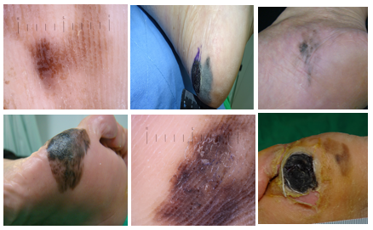
Fig. 2. 1 Various characteristics of ALM

Melanoma in Situ
Melanoma in situ has explained a substantial part of the ongoing increase in melanomas, which has persisted over 30 years. Epidemiologic and clinical studies have contributed to our understanding of melanoma in situ. In discussing melanoma in situ, it also cannot be obviated to discuss its pathology and biological behavior as well as treatment whether they are similar or diverged from that of malignant melanomas [79].
Although melanoma has become somewhat more common over the last 3 decades, a remarkable proportion of this rise appears to consist of in situ disease. The latter is allowed a diagnosis only if queried appropriately because, per the American Joint Committee on Cancer [80], these are melanomas that ONLY or primarily (WHO classification) involve heading. Lentigo maligna is histologically a subtype of MIS that contains characteristic melanocytes. The overall incidence of MIS and invasive melanoma has risen by 2.6 % per year during the past decade, driven primarily by an increase in MIS alone [81], which increased at an annual rate of 9.5%, becoming one of the most rapidly evolving malignancies across all SEER database [82]. The rapidly rising skin biopsy rates between 1968 and 2001 were also obviously linked with an increase in the diagnoses of melanoma during this period [83], which added fuel to these controversies further [84, 85]. However, it is associated with an increased risk of developing second primary tumors[86, 87]. Patients with MIS are considered at excessive risk of developing a subsequent primary MM; dermatologists have therefore recommended regular follow-up for new melanoma in these individuals [88, 89].Despite these suggestions, the evidence available on early detection through screening and prevention of MIS using sun avoidance and protection strategies is uncertain because controlled trials are challenging to conduct. Effective screening by a physician requires MIS to be diagnosable on clinical examination. These tumours can be challenging to distinguish from benign pigmented lesions, especially in sun-exposed areas. Even though diagnostic aids, such as dermoscopy can be very helpful in the diagnosis of MIS, a biopsy is always needed for definitive confirmation.
Incidence
The number of MIS has been estimated to have been rising steadily over the past decade. This number is seen to rise faster in patients aged between 20 and 49 years than in the older group and very much in men as opposed to women. The highest annual change percentage in any tumour has been reported in the SEER database MIS. In Europe, Australia, and the United States, MIS makes up a bigger proportion of the annual rise in melanoma. In Queensland, MIS rose by 10.6% and 8.5%, and invasive melanoma decreased by 2.6% and 1.2% between 1982 and 2002 for men and women, respectively. In the United States, MIS rose from < 1 case/100,000 patients in 1973 to 14 cases/100,000 patients in 2006. This rapid rise has been occurring at an ACP of 9.5% per annum and is higher than that in invasive melanomas. According to the SEER, younger patients, notably 20 to 49-year-olds, have a faster-rising percentage for MIS, and men are more frequently diagnosed with MIS in comparison to women: men, 55.7%, versus women, 44.3%. The patients diagnosed with MIS had an average age of 61.2 years, and whites made up the largest percentage of patients at 93.1%. Comparatively, patients diagnosed with MM had an average age of 54 years, with men making up 53.4% of patients. Probably the most common locations of MIS are in the head and neck. On the other hand, only 18.2% show involvement of the head and neck which is positioned as the fourth most common site in MM after the trunk (32%), upper extremities (23.4%) and lower extremities (20.3%). Conclusion - A truly rapid increase in the incidence of MIS, unless due to over-detection, justifies public health control efforts against this disease.
There has been controversy as to whether the incidence of melanoma in situ has increased or whether it is simply being more frequently diagnosed. The apparent increase in incidence and increased diagnoses may be due to changed histologic criteria, increased reporting, or improved screening.
Given the rising incidence of MIS, several times in the past there has been skepticism among clinicians regarding whether this clinical scenario remains poorly understood and might represent an epidemic with increased tumor burden, an apparent increase due to improved screening and reporting, or changes in histologic criteria. In their population-based analysis of the linked SEER-Medicare data, Welch et al. found that the biopsy rate within the Medicare population increased 2.5-fold from 1986 to 2001 [90]. The incidence of MM increased 2.4-fold over this period which may be indicating the increasing biopsy rates are associated with enhancement in invasive melanoma diagnosis. For every 1000 biopsy specimens, 4.4 diagnoses of MIS were estimated. Several studies examining MM by tumor thickness and sociodemographic factors have demonstrated that there is no significant effect of increased screening with biopsy alone on the higher incidence of this malignancy, particularly during a time when an elevated incidence occurred irrespective of socioeconomic status (a surrogate for access to care/screening). There has been speculation that a portion of the rise in MIS is due to the over-diagnosis of melanocytic lesions as malignant more broadly. Permission was obtained to re-review the dysplastic nevi and radial growth phase melanomas retrospectively diagnosed on slides from 1988-1990 as part of one study by a panel of dermato-pathologists in February 2008, and March-May, 2009. The mean number of melanomas diagnosed from 1988 to 1990 was 11; this includes the average number of melanomas diagnosed from the familiar slides in 2008 and 2009 was 18. These studies did not specifically discuss MIS, which makes it challenging to say clearly whether the incidence of MIS is truly rising or whether it reflects increased diagnostic scrutiny.
Risk of secondary tumours and mortality
Patients who develop in situ melanoma have a higher risk for the development of subsequent primary malignancies. The most common secondary tumor to be diagnosed is malignant melanoma, which proved to be a second primary. The life expectancy of patients with melanoma in situ is equal to the wider community.
Like MM, for MIS a significant risk of developing second primary malignancies was observed (SIR, 1.2 [95% CI, 1.2-1.3]), most notably MM (SIR, 8.1 [95% CI, 7.7-8.6]), when compared with whole-body surveillance in the general population. Consequential malignancies identified following MIS, which involved lip malignancies (SIR, 1.7 [95% CI, 1.1-2.6]), and leukaemia. There was reduced risk for malignancy involving the digestive system (SIR, 0.8 [95% CI, 0.7-0.8]), colon/rectum/anus cancers (SIR, 0.8 [95% CI, 0.7-0.9]), pancreatic cancer (SIR, 0.8 [95% CI, 0.6-0.9]), liver/gallbladder/biliary ducts (SIR, 0.7 [95% CI], 0). The average time to a detect of a second tumor, of any kind of cancer, was 1-4 years. Although additional research is necessary, this relationship might relate to genetic or environmental factors that predispose those diagnosed with MIS to succumb to additional malignancies or decrease the likelihood of others. Patients with MIS have a normal life expectancy. In contrast, the 5-year mortality of patients with MM is higher than in the general population although it has been diminishing in the last 3 decades.
Screening recommendations
Research evidence cannot support the effectiveness of a complete body skin inspection in situ in detecting melanoma at sites of primary care physicians. Some studies have suggested that it may be of benefit for dermatologists to screen for melanoma in situ, particularly in higher-risk patients.
Thus, sunscreen application can prevent, or at least moderate, suntan reduction by reducing the effects of UV on the skin. In vitro studies using animal models ubiquitously confirm this function for sunscreens. Sunscreens are one of the most prevalent ways in which the general population seeks protection from the sun, although their application is often highly inadequate. Testing is done on the human skin surface at an applied thickness of SPF 2mg/cm2. The usage of sunscreen has the potential to reduce the incidence of melanoma although sun exposure is thought to be a key risk factor for the disease. A dependable marker of melanoma, the formation of melanocytic nevi, decreased in children's randomized sunscreen trials. Nevertheless, the effects of MIS and MM were not examined in these investigations. While some studies found no correlation between routinely using SPF 15+ sunscreen and other sun protection techniques and a lower risk of melanoma, others did indicate such a correlation. In one pooled analysis of 11 case-controlled studies including a total of 9067 individuals’ the relative risk was 1.01, showing no relationship between sunscreen use and melanoma development. Additional reports have indicated there is evidence that sunscreen use places an individual at a higher risk for melanoma because people who apply sunscreen are exposed to the sun for a longer period. Until 2011, there was no RCT (randomized controlled trials) evidence to inform the effect of sunscreen on melanoma. In 2011 Green and co-authors reported evidence from a randomized community trial of the effect of sunscreen use, and sun protection services in Queensland, Australia. A Randomized Study of 1621 was randomized and treated with an SPF16 sunscreen.
However, despite the lack of solid evidence as to their benefit against MIS prevention, they are hyped up and still recommended by dermatologists for use in the general public. Seriously, those other advantages of sunscreen are very good benefits like decreasing actinic keratoses and preventing squamous cell carcinoma (slowing down sunburn-related erythema) which make its use totally rational in high-risk populations. Sunscreen Use Increases After Melanoma Diagnosis. This would become inconsistent over time and resembles that noted in the group without a history of melanoma. These behavioural patterns could account for part of the data on patients diagnosed with MIS, but more research in this area is required to identify the patterns of sun-protective behaviour acquired by people accompanied by a study of MIS.

Clinical features
Clinical and dermoscopic characteristics of Melanoma in situ may help differentiate it from typical nevi. As per the World Health Organization, lentigo maligna is classified as melanoma in situ.
MIS may be different in size, shape, and colour. In a study of 121 MIS lesions, 77% of lesions were >6mm, 92% were macular, and 75% were asymmetric. Most lesions had an irregular border, although not a poorly defined one. Most of the tumour colour was black (48%), followed by brown (41%), tan (16%), grey (85%), and pink (3%). The majority of color lesions (98%) had >1 color present in the lesion [96]. Lentigo maligna (LM) subtype, almost always arises on the sun-exposed skin of long-term duration as is the case in preventative LM melanoma.

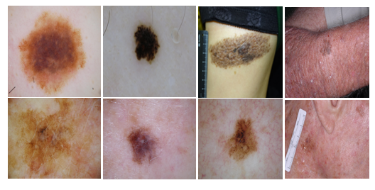
Fig. 2. 2 Characteristic variations in MIS
In other words, the frequency of MIS spread within the last thirty years, and it did not affect mortality or diminish life expectancy. There is a debate about whether the increased frequency of MIS represents overdiagnosis or reflects more biopsies and increased sensitivity of detection methods. The USPTF does not currently recommend full-body skin examinations for the general population. This group does not address the issue of screening in a high-risk population, which involves "persons with a personal or significant family history of skin cancer." Reducing the incidence of MM by sunscreen use appears to be quite possible, although the effect on MIS may not be as great.

Nodular Melanoma
The most aggressive type of melanoma is nodular melanoma. It occurs when cells in the skin called melanocytes become malignant. Melanocytes are skin cells that produce melanin. Occasionally, these cells can mutate following exposure to ultraviolet (UV) radiation from the sun or aesthetic sources such as laser or tanning beds[90]. Like all types of skin cancers, it has been predicted that approximately 9500 people will be receiving a skin cancer diagnosis in the US each day.
Incidence
NM is more commonly diagnosed in older adults with a higher incidence in individuals over 60 years of age. The prevalence is higher in men compared to women. Nodular Melanoma accounts for about 15-30% of all melanoma cases. Nevertheless, based on the characteristics of dermoscopy , it grows more quickly than other types of melanomas, making it the most aggressive kind of malignancy. Melanoma often develops in four phases, the last of which is metastasis, or the spread of cancer beyond the original tumour. The US Surveillance, epidemiology and End Result Program has estimated that there are 793,283 people are living in the United States with a history of invasive melanoma and the case number for males is 408,229 [98]. The US melanoma incidence rate was 6.8 per 1,00,000 in the period from 1973 to and by 2003-2007, this rate had grown to 20.1 per 1,00,000. A study from 2014-2018 indicated that the age-standardized incidence rate of melanoma in Australia was around 54 cases per 100,000 people per year with NM.
Recently melanoma cases have been increasing, yet its basis has not been fully explained. There are several controversies surrounding the incidence rates of nodular melanoma. This study reported current controversies in early-stage melanoma, incidence, screening and histologic regression [99]. Some experts believe that the nodular melanoma increase, and overall melanoma in general may be partly a result of improved diagnosis and increased awareness of the condition, not represent a real case. The controversy about overdiagnosis and misclassification of melanoma subtypes became a concern. Because lesions diagnosed as nodular melanoma may be early or in situ melanomas, these types are misclassified in incidence reports. The controversy about sun exposure: excessive UV exposure is quite clearly an established risk factor, while on the other hand, some people believe that too little of the same sunlight may also lead to health consequences.

Risk of secondary tumors and mortality
Nodular melanoma is known for its rapid vertical growth, which increases the likelihood of metastasis and secondary tumours compared to other melanoma subtypes. Secondary tumours from nodular melanoma often occur in vital organs such as the lungs, liver, brain, and bones due to the propensity for early hematogenous spread. The risk of secondary tumours is strongly linked to the thickness of the primary tumour, thicker tumours (>4 mm) have a significantly higher risk of metastasis. Mutations in genes such as BRAF and NRAS are associated with increased metastatic potential and the formation of secondary tumours in nodular melanoma. Nodular melanoma often metastasises more quickly than other types of melanomas, sometimes within months of the initial diagnosis if not detected and treated early. Nodular melanoma has a poorer prognosis compared to other melanoma subtypes, the 5-year survival rate is lower, particularly for cases diagnosed at a later stage. Early detection is crucial for better outcomes, patients diagnosed with localised NM have a significantly better prognosis compared to those with regional metastases. Older age, male gender, and certain genetic predispositions are associated with worse outcomes in NM. These factors can influence both the risk of secondary tumours and overall mortality.
Screening recommendations
Individuals at high risk for melanoma should have regular skin checks by a dermatologist, typically every 6-12 months. High-risk groups include those with a family history of melanoma, a personal history of skin cancer, numerous or atypical moles, and fair skin with a history of sunburns. The dermatologist suggests a baseline full-body skin examination for adults, especially those over 40 or those with significant risk factors. Dermoscopy is a non-invasive imaging technique that allows for a more detailed examination of skin lesions, it can improve the accuracy of melanoma detection and should be used during skin exam. For high-risk patients, total body photography can be an effective tool to monitor changes in the skin over time.

Sunscreen uses
Regular use of sunscreen significantly reduces the prospect of developing skin cancers, which include melanoma, basal cell carcinoma, and squamous cell carcinoma. Sunscreen acts by blocking or absorbing harmful UV radiation that can damage skin cells. Nodular melanoma can occur anywhere on the body but is mostly found on the trunk in men and the lower extremities in women. It can also appear on the scalp and neck.[91]
Broad-spectrum protection[92]: This will protect against both UVA and UVB rays. UVA rays contribute to skin ageing and UVB rays are primarily responsible for sunburn; both types can increase the risk of skin cancer. SPF Value: Sunscreens should have an SPF (Sun Protection Factor)[93] of at least 30. Higher SPF values provide more protection, though the incremental benefit decreases beyond SPF 50.
Clinical features
NM can occur anywhere on the body most commonly on the trunk, legs, scalp, and neck. It is more commonly diagnosed in middle-aged and older adults. Men are more frequently affected than women. It is often firm to the touch and may be uniform in colour, appearing as black, blue-black, or red. This subtype of melanoma is characterized by its rapid vertical growth phase, it tends to grow more quickly than other types of melanomas, often developing over weeks to months. NM frequently ulcerate and bleeds. These features are indicative of more aggressive disease and warrant immediate medical attention. While early-stage nodular melanoma may be asymptomatic, advanced lesions can become painful, tender, or itchy.
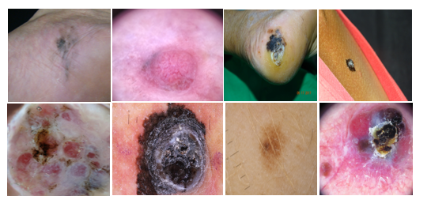
Fig. 2. 3 Characteristic variations in NM

Superficial Spreading Melanoma
Superficial spreading melanoma grows out along the top layer of skin before growing deeper down into the skin. It is the most common kind of melanoma, 70-80 out of every 100 people with melanoma have this type, and it can develop anywhere on the body. It is common in males and females, only 15% of melanomas arise before age 40, and it is rare under age 20 (<1%).
It tends to occur at sites of intermittent, intense sun exposure, especially on the trunk in males (40%) and the legs in females (40%). This study analyzed 97702 cases using the SEER database of SSM [94, 95].
Incidence
SSM represents approximately 70% of melanomas. SSM prevails in younger subjects, showing its peak in the age range between 30 and 50 years. It is also, very slightly, more frequent in women than in men. The incidence rates of SSM vary geographically; the areas of greater UV exposure for example, Australia and New Zealand have a higher incidence of the condition. It also tends to occur more frequently in countries with fair-skinned populations, such as Northern Europe and North America. Known major risk factors for the disease include fair skin, a history of sunburns, extensive UV exposure both due to natural and artificial sources, a high number of nevi, and a family history of melanoma. SSM is more prevalent in Caucasians compared to other racial and ethnic groups [96]. However, it can occur in all types of skin. The difference lies in its presentation regarding skin color pigmentation. This increased awareness and regular examination of skin lesions have resulted in the diagnosis of SSM at an earlier stage and, thus better prognosis. It is an awareness of sun safety and check of skin by public health campaigns that enable early diagnosis. The prognosis for SSM was relatively good compared to other melanoma subtypes, especially if it is an early diagnosis. This, to an extent, will depend on the thickness of the tumor at the time it is diagnosed.
The overview of the controversies surrounding the incidence of SSM highlights the complexity of factors involved in melanoma. The controversy about rising incidence rates in SSM reflect a true rise in disease occurrence or if they are due to improved detection and diagnostic practices. Some experts suggest that the increase in diagnosed cases may be partly due to overdiagnosis. The other controversy is about sun exposure, the complexity of UV exposure patterns and genetic predispositions makes it difficult to isolate specific causes. Changes in lifestyle and environmental factors over the past decades, such as increased outdoor activities and travel to sunnier climates, might contribute to the rise in melanoma cases. However, quantifying the impact of these factors on incidence rates is challenging and controversial. Controversy exists over whether increased screening leads to improved outcomes or simply inflates incidence statistics without significantly impacting mortality rates [97].

Risk of secondary tumours and mortality
SSM has a significant potential to metastasize if not detected and treated early, while the risk of metastasis increases with tumour thickness. Tumor thickness is a crucial factor in determining the risk of secondary tumors, thicker tumors (>1mm) have a higher chance of getting melanoma. The most common occurring areas of secondary tumours is lymph nodes, lungs, and bones. The overall 5-year survival is 95.30% and is increasing steadily [98].
Screening recommendations
Certain individuals are at higher risk for melanoma and may benefit from more intensive screening. This includes people with a history of melanoma, those who are immunosuppressed, and individuals with a significant number of dysplastic nevi (atypical moles). Dermatologist suggest a few screenings such as regular skin examinations, Total body photography, and digital monitoring.
Combination of screening methods: Using multiple screening methods together can enhance early detection of melanoma. Visual inspections, dermoscopy, TBP, and digital monitoring tools can all complement each other. A multidisciplinary approach involving primary care physicians, dermatologists, and patient self-examinations is often the most effective[99, 100].
Follow-Up and Monitoring: Consistent follow-up and monitoring are crucial for individuals with a history of SSM or other skin cancers. Regular check-ups can detect recurrent or new melanomas early, improving treatment outcomes. Patients should adhere to their dermatologist's recommendations for follow-up schedules and promptly report any changes or new symptoms.
Sunscreen uses
Sunscreen protects the skin against the melanoma. Sunscreen applied regularly decreases the risk of developing skin cancers. by blocking or absorbing UV radiation, sunscreen prevents DNA damage in skin cells that can lead to cancer. Apply sunscreen generously to all exposed skin at least 15-30 minutes before going outside. An average adult should use about one ounce to cover the entire body.
Clinical features
Superficial spreading melanoma is the most common type of melanoma on skin and mucous membranes, accounting for approximately 80% of all lesions. Superficial spreading melanoma is mostly found in middle-aged patients. The radial-growth phase consists of a tan, brown, or black variegated macule or plaque that exhibits an irregular outline (Fig. 2.4).
Frequently, one or more nearby satellite lesions are present. The radial growth phase may last from several months to several years. During this phase, the lesion becomes larger, more intensely pigmented, and eventually nodular and ulcerated.

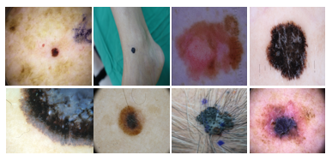
Fig. 2. 4 Characteristic variations in SSM

METHODOLOGY, HYPERSPECTRAL IMAGING, AND SPECTRUM-AIDED VISUAL ENHANCER

Hyperspectral Imaging
The conversion process is specially built to transfer a WLI RGB image taken by a digital camera to an HSI image, as shown in Fig. 3.3. At the outset, the Reference between the WLI image and the spectrometer image in terms of various colors has to be calibrated. Macbeth Color Checker (X-Rite Classic) is defined as target colors for calibration. The color calibration tool used has 24 squares with altogether different samples of colors that are commonly found in nature, like red, green, blue, cyan, magenta, yellow, and six shades of grey. In the last few years, cameras from X-Rite are thought to be a part for color calibration. In the present study, the digital camera was used to photograph images with colors that critically matched the X-Rite board (target) colors. The next step was to convert the 24-colour patch image into the CIE 1931 XYZ color space. The digital camera image was taken in the native image format JPEG in the standard RGB color space of a digital camera, which is sRGB. More specifically, the sRGB values (0 to 255) in R, G, and B first were linearized into a reduced gamut ∈ [0, 1]. Then, the reduced sRGB values were mapped onto linearized RGB values using the Gamma function. This study uses a translation matrix to translate the linearized RGB values into the CIE 1931 color space while representing the numerical relationship of the wavelengths in VIS to the color 47 observed in nature. However, the images taken from a digital camera might be nonlinear response, dark current, incorrect color separation, or color shift. The matrix Equation 3.1 is used as a variable to solve the problem.

[C] = [XYZSpectrum] × Pinv ([ V]) (3.1)

[XYZcorrect] = [C] × [V] (3.2)

The discrete alteration formulas to adapt the 24-colour patch image and 24-colour patch reflectance spectrum data to XYZ colour space are as follows on the camera part: alter sRGB colour gamut space to XYZ colour gamut space

$\left[\begin{matrix}X \\ Y \\ Z\end{matrix}\right]$ = [MA][T] $\left[\begin{matrix}f(RsRGB) \\ f(GsRGB) \\ f(BsRGB)\end{matrix}\right]$ × 100, 0 ≤ $\begin{matrix}RsRGB \\ GsRGB \\ BsRGB\end{matrix}$ ≤ 1 (3.3)

[T] = $\left[\begin{matrix}0.4104 & 0.3576 & 0.1805 \\ 0.2126 & 0.7152 & 0.722 \\ 0.0193 & 0.1192 & 0.9505\end{matrix}\right]$ (3.4)

$f\left(n\right)=\left\{\begin{aligned}\left(\frac{n+0.055}{1.055}\right)2.4, &n>0.04045 \\ \left(\frac{n}{12.92}\right) , &otherwise\end{aligned}\right.$ (3.5)

[MA] = $\left[\begin{matrix}\frac{XSW}{XCW} & 0 & 0 \\ 0 & \frac{YSW}{YCW} & 0 \\ 0 & 0 & \frac{ZSW}{ZCW}\end{matrix}\right]$ (3.6)
On the spectrometer part: adapt reflection spectral data to XYZ color gamut space
𝑋 = k $\int_{400nm}^{700nm}{S(λ)R(λ)x̅(λ)dλ}$ (3.7)
Y = k$\int_{400nm}^{700nm}{S\left(λ\right)R\left(λ\right)y̅(λ)dλ}$ (3.8)
Z = k$\int_{400nm}^{700nm}{S(λ)R(λ)z̅(λ)dλ}$ (3.9)
K = k$\int_{400nm}^{700nm}{S(λ)R(λ)y̅(λ)dλ}$ (3.10)
The nonlinear response of the camera can be modified by a third-order formula, and the nonlinear response alteration variable is demarcated as VNon-linear.

𝑉_{𝑁𝑜𝑛−𝑙𝑖𝑛𝑒𝑎𝑟} = [𝑋 ³ 𝑌 ³ 𝑍 ³ 𝑋 ² 𝑌 ² 𝑌 ² 𝑋 𝑌 𝑍 1] T (3.11)

Within the dark current component of an imaging device, the dark current typically maintains a consistent value regardless of the quantity of light received. As such, a fixed value is assigned to represent the dark current's contribution, and the dark current modification variable is established accordingly V_{Dark}.
The XYZ_{Correct} and XYZ_{Spectrum} must be changed from XYZ color space into the lab color space before using CIE DE2000 to determine the color difference. The colors the reflectance spectrum yielded were very similar to those depicting the measured values. System performance was first sorted out by using artificial data. Spectral emissions of the LEDs are considered to be taken from the characterization of the LEDs, and the sensitivities were obtained from the camera manufacturer. The 24-color Macbeth Color Checker chart was used to set the spectral curve of the training and validation samples. Color difference results before and after of calibration are shown in Fig. 3.1. After the calibration, the color became very similar to the color obtained by the spectral analyzer and the difference was difficult to differentiate. The average chromatic aberration of all 24-color blocks was 10.76 before the camera was calibrated. After the calibration of the camera, the average chromatic aberration dropped as low as 0.63. Fig. 3.2 shows the lab values of the simulated and observed colors of average color difference is 0.75.
Initially before transformation, a dependency of WLI and spectrometer for different colours was to be created. In the calibration process, the Macbeth colour checker was set as a target. It had 24 squares with examples of colours one might find in nature on the wide range, like, red, green, blue, cyan, magenta, and yellow, six shades of grey represented. Recently, the X-Rite has entered more into the limelight due to its preference for colour calibration. Very understandably, most pictures clicked by the endoscopy camera were of colours relevant to the X-Rite board which served as a target. The image consisting of 24-colour patches was converted into the CIEDE 2000 XYZ colour space. Captured in JPEG format within the standard RGB colour space, the R, G, and B values, ranging between 0 and 255 in the sRGB colour space, were first adjusted to a small gamut ranging from 0 to 1. Afterwards, applying the gamma function, these scaled sRGB values were further transformed into linearized RGB values. Further, the linearized RGB values were then translated into the CIEDE 2000 colour space using a translation matrix. In this way, the numerical correlation was obtained between the wavelengths in SAVE and the natural colours obtained. Although there is a significant difference in band between 450 and 540 nm range, the intensity is identical in some wavelengths. Spectrum is converted into an HSI with a 1 nm spectral resolution in the range from 380 to 780 nm. The results showed that some of the typical bands in the visible light absorption spectrum for skin irradiation are between 405–435 nm and 525–555 nm because of the change in absorption intensity and wavelength position of visible light by haemoglobin in the blood flow. Important parts of skin lesions are extracted using wavelengths in the range of 435 and 525–555 nm, and the output obtains the SAVE image. Using the above method, an RGB image captured by the digital camera was converted into an HSI image

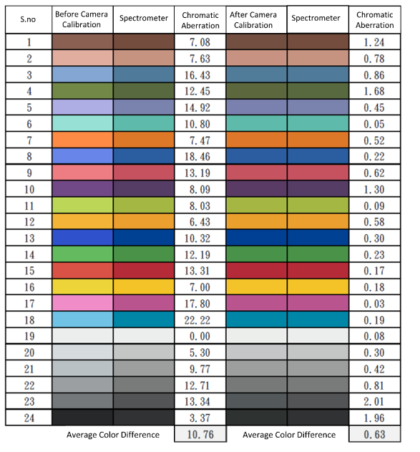
Fig. 3. 1 Color difference before and after camera calibration
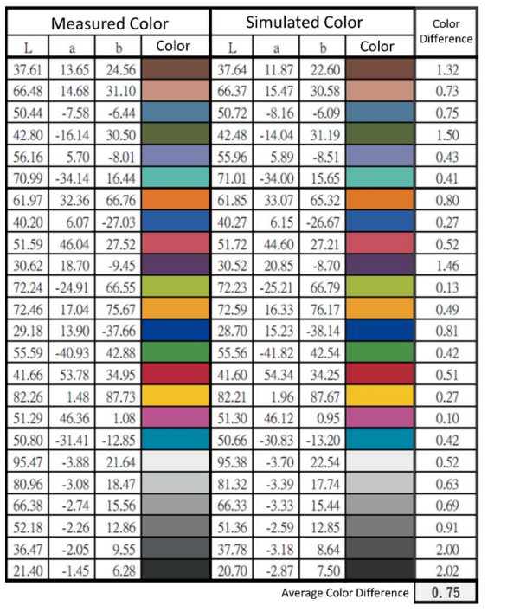
Fig. 3. 2 LAB values of the simulated and observed colors

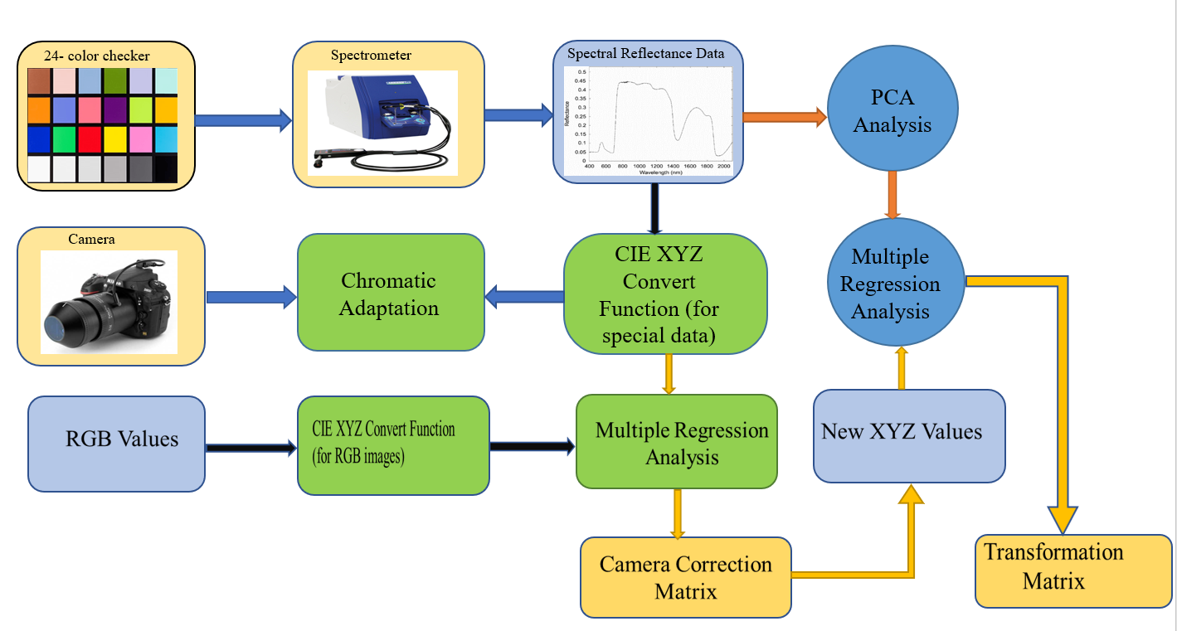
Fig. 3. 3 Schematics of the developed HSI algorithm

3.2 Spectrum-Aided Visual Enhancer
The SAVE technique played a very important role in this research while constructing the dataset SAVE. It would convert a WLI RGB image captured using a digital camera into a SAVE image shown in Fig. 3.4 The first step in the conversion is a spectral analysis of an WLI RGB image. It applies differently the wavelength distribution of each WLI image in RGB channel. We can tell that how much specific wavelengths are making the image by analyzing its spectral properties. Once the spectral analysis is completed, we proceed to extract out specific narrow bands which are required for SAVE. Blue (415nm) and green light (540 nm), which are critical for the early detection of skin cancer. We separate these wavelengths from the WLI image by spectral unmixing algorithms or band-pass filters. Blue channel extraction looks at the part of the image that relates to 415 nm, while green channel extraction isolates out anything that is based on a wavelength equivalent to 540nm. After extracting the corresponding wavelengths, we unify these bands to render a SAVE image. This is the new extracted 415 nm data in Blue, and 540m in green channel. Superficial and deeper skin structures are highlighted in this combination, which bring the abnormalities to light. In layman terms, this conversion process can be achieved using programming such as Python where we apply certain algorithms and filters to extract required light bands and then merge them together. Band-pass filtering functions are used to separate the needed wavelengths and image processing methods can improve the final SAVE image. The systematic methodology adapts the wideband WLI image to SAVE mode that enhances diagnostic capabilities.
The technique of spectral-aided visual enhancer for converting WLI RGB images to NBI involves one series step (spectral analysis, wavelength extraction, image reconstruction and enhancement) well designed. Greater visualization of essential structures results in more accurate diagnosis and analysis of medical conditions, like skin cancer thus promoting a better diagnostic approach leading to an improved treatment outcome. The average colour difference between constructed SAVE and the observed colour is shown in Fig.3.5.

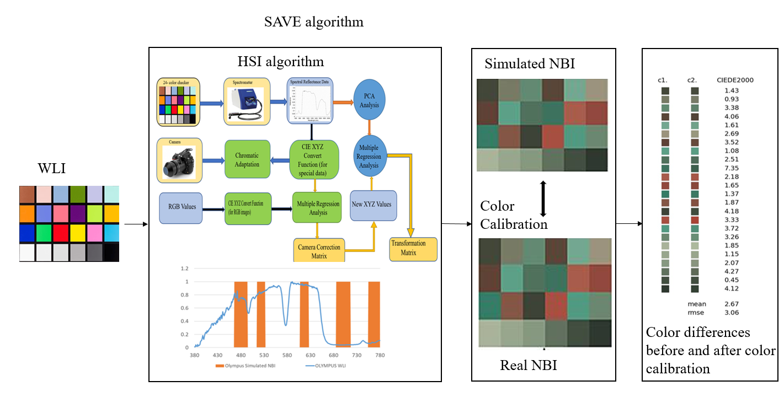
Fig. 3. 4 Schematics of the developed SAVE algorithm

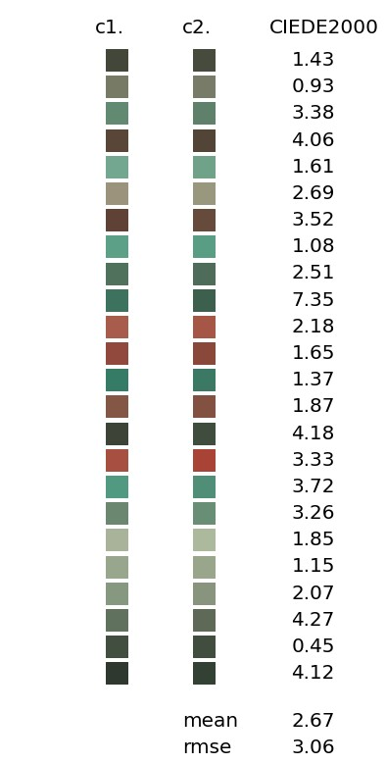
Fig. 3. 5 Color difference of the simulated and observed SAVE colours

3.3 Experimental Setup
An experimental setup is an integral part of a model's accuracy and robustness. It comprises normally a few major elements, including properly preparing a diversified dataset, following judicious pre-processing techniques, and setting up appropriate objective evaluation methods. This experimental setup starts with the assembling and normalizing of a very large compilation of real data annotated with precision, spanning contexts and scenarios that are to be run across to exercise the model comprehensively.
This project work was done using a system with Windows 10, CPU – Intel® Core TM i5-3470 64-core processor 3.2 GHz, backed by 64GB primary storage RAM, GPU– Nvidia GeForce RTX 3080 Ti 44GB, and Google Collaboratory, commonly known as Google Colab. The hospital provided a few datasets that were very important for the proposed study, and the rest were from the ISIC repository. Further detailed research at the individual level of lesions' variability might enhance classification accuracy.
Meanwhile, contribution through techniques via Jupyter Notebooks is what will allow others to reproduce steps and improve even more on the methods. Continued access to these kinds of evolving resources will keep pushing further and further the progress of collaboration in automated disease detection.

3.4 Methodology

3.4.1 Dataset
This study focuses on four skin-related diseases: ALM, NM, Min situ, and SSM. The training dataset plays a pivotal role in developing and evaluating DL models for skin cancer detection. It serves as the foundation for the model to recognise and classify cancerous lesions from medical images. Here we have two different types of datasets to train the model one is white light (WLI), and the other is a SAVE dataset. The dataset used to train the algorithm comprises 878 images categorized into four types Acral lentiginous melanoma, Melanoma in situ, Nodular melanoma, and Superficial spreading melanoma to train the model shown in Table 3.1. The entire study is split into four sections: SAVE algorithm, data pre-processing, model training, and model evaluations shown in Fig. 3.6.

Table 3. 1 The distribution of the dataset for training and testing sets
No | Classification | Train | Validation | Test
1 | Acral Lentiginous Melanoma | 287 | 29 | 26
2 | Melanoma in Situ | 164 | 11 | 8
3 | Nodular Melanoma | 84 | 10 | 6
4 | Superficial Spreading Melanoma | 223 | 20 | 10

Table 3. 2 The distribution of dataset images
No | Classification | Clinic images | Dermoscopic images | Closeup images
1 | Acral Lentiginous Melanoma | 101 | 11 | 230
2 | Melanoma in Situ | 135 | 19 | 20
3 | Nodular Melanoma | 25 | 15 | 60
4 | Superficial Spreading Melanoma | 184 | 34 | 35

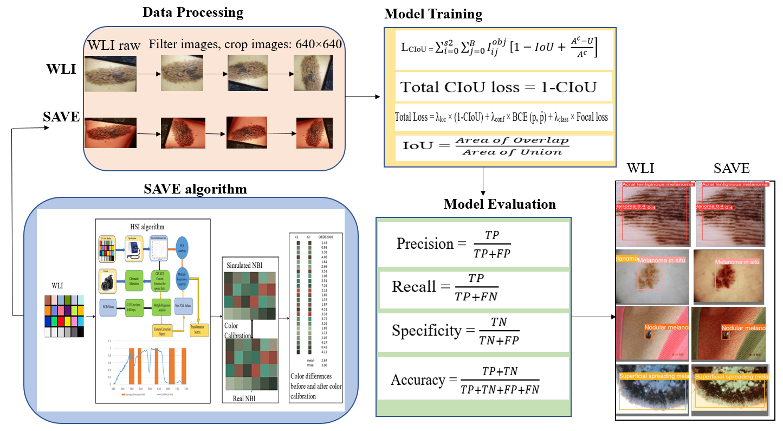
Fig. 3. 6 An Overall flow diagram for this project

3.4.2 Data Pre-processing
The melanoma detection pre-processing phase will ensure that there is a proper data source to make predictions of the model precisely in real-time. Pre-processing would detect methods since images may have much noise resulting from rough lighting, skin surface light reflection, hair and other factors that affect classification performance and should be minimized to achieve better classification. It will also help to manage model accuracy and reduce complexity. Data augmentation is proposed to inflate the sample size, which is unstable classes avoiding biased predictions due to class imbalance issues. Following data augmentation used to increase dataset variability: Rotation and shear are 90 degrees clockwise, anti-clockwise, ±10 degrees horizontal and vertical using a Pytorch. We used roboflow to check classification imbalance.

3.4.3 Splitting the Dataset
Machine learning normally classified the data into two major groups. The two types of groups are the training and test groups. While the training dataset is especially used to train the produced model, a test dataset will be used to evaluate the model's accuracy, sensitivity, and specificity. This study adopted a 70/20/10 split, where 70% of the data is used for training, which is 758 images; 20% is used for validation, which is 70 images; and 10%, which is 50 images, is used for testing. Overfitting and underfitting issues may arise based on how the data is divided for testing and training. Unless the data used for training is too much, there would then be an overheated fitting of the model; but if not, enough data are used in training, underfitting problems occur.

3.5 Yolov5-N Model
The YOLO model is a real-time object discovery model that identifies and classifies objects in a single pass of the image. This model exercises a single conventional neural network to convert the target discovery issue into a retrogression issue that excerpts Bboxes and class changes directly from the image. The former studies proposed a deep neural network-grounded automated frame to classify lesions from seven types of skin lesions. YOLOv5 has three main corridors backbone, neck, and head. YoloV5 uses CSPDarknet53 as its backbone. It leverages the Darknet53 armature proposed and implements a CSPNet strategy to divide the point chart of the base subcase into two corridors, which are also intermingled through across-stage scale. In the neck section, Panet is employed to produce the point conglomerations network (FPN) and enable the birth of multi-scale point charts. This structure allows for the birth of features optimized for Nano, small, medium, and large object discovery.
Backbone is the armature of the conventional neural network (CNN) and is substantially composed of models, as focus, CONV- BN- Leaky ReLU (CBL), cross-stage partial (CBP), and spatial aggregate pooling (SPP) models. The function of focus is to slice the input image, reduce the needed CUDA memory and number of layers, increase forward and back propagation speed, aggregate different fine-granulated images, and form image features. Focus reduces the input image's dimension to speed up training by cutting the original 640 × 640 × 3 image into four 320 × 320 × 3 images. It also runs the input image via CONCAT in combination with slices and layers of traditional kernels to produce a 320 × 320 × 32 image. Neck consists of CBL, Up sample, CSP2_X, and other models it's a series of point aggregation layers that combines image features and generates point aggregate (FPN) and path aggregation (visage) networks. YOLOv5 has the theCSP1_X structure of the YOLOv4 interpretation CSPDarknet- 53 and also adds the CSP2_X structure to reduce the model size and excerpt decreasingly complete image features. Head uses the bounding box function, GIoU Loss. YOLOv5 contains three types of loss functions: the bounding box loss, which is a regression loss, confidence loss, and classification loss. To enhance the detection performance of the model on the occluded melanoma, the GIoU loss value was replaced with the CIoU loss value which is more applicable in detecting occluded targets as a border loss function. The CIoU loss is calculated as follows:

Total Loss = $L_{box }+$ $L_{cls}$+${ L}_{obj}$ (3.12)

Loss = $L_{classification}$ + $L_{confidence}$ + $L_{CIoU}$ (3.13)

L_{CIoU =} $\sum_{i=0}^{s2}{\sum_{j=0}^{B}{I_{ij}^{obj}}}\left[1-IoU+ \right.\left.\frac{A^{c}-U}{A^{c}}\right]$ (3.14)

3.6 YOLOv8-N Model
Published in January 2023, YOLOv8 has remained in the lineups of real-time object detection models and is present to find real-time object performance through significantly advanced object detection architecture. A single-shot detection approach is accepted that holds the capacity for concurrent identification of a number of objects in the picture. The major components that make up the YoloV8 are the backbone, neck, and head. For example, the backbone has 53 convolutional layers, while the neck has 225 layers in the Yolov8n model. The pre-trained CNN backbone extracts low, medium, and high-level feature maps of an input image. The feature pyramid network and other path aggregation blocks are used by the neck to concatenate such feature maps. This is a model enabling the use of pre-trained models, which are already trained on a very large dataset, like COCO—Common Objects in Context. The models learned how to classify and recognize objects in an image. The algorithm creates a grid out of an image, where each cell represents a predicted number of bounding boxes. The skin lesion photos are normalized and scaled, and the dataset is divided into training, validation, and test sets. Transfer learning strategies are then applied to improve the YOLOv8 model. In essence, a pre-trained YOLOv8 model is fine-tuned using the training set through transfer learning. During fine-tuning, an optimization algorithm was used, and at the same time, data augmentation techniques were employed to help boost the model's understanding. It also defines specific hyperparameters and uses them to tune the fine-tuned YOLOv8 model to the optimum performance. The loss functions are crucial components that guide the model training by measuring the difference between the predicted outputs and the actual targets. The localization loss measures the error in the predicted bounding box coordinates compared to the ground truth. The IoU loss of the bounding box measures the overlap between the predicted and ground truth bounding boxes, encouraging better localization of objects in the image.
IoU = $\frac{\left|B∩B̂\right|}{\left|B∪B̂\right|}$ (3.15)
IoULoss = 1-IoU (3.16)
Where B and B̂ are the ground truth and predicted bounding boxes respectively. The complete IoU loss of the bounding box is as follows.
CIoU = DIoU ̵ αν (3.17)
α = $\frac{ϑ}{\left(1-IoU\right)+ϑ}$ (3.18)
Total CIoU loss = 1-CioU (3.19)

3.7 YOLOv9 Model
A notable development in real-time object detection is YOLOv9.It presents novel methods including the generalized efficient layer aggregation network (GELAN), and programable gradient information (PGI). In YOLOv9, a novel idea called PGI was presented to address the problem of the information bottleneck. This ensures meaningful data throughout the enormously deep network layers, which enables the generation of unreliable gradients. It permitted the model to have accurate updates and helped improve overall detection performance. This model comes to set new benchmarks with its impressive efficiency, accuracy, and flexibility on the MS COCO dataset. This new model is more accurate and more efficient than the previous one. Training on the pre-processed dataset is done using the YOLOv9e model. This model has 192.5B computational flops, 58.1M parameters, and a picture size of 640 × 640. While training the model and the prediction there are losses in object detection. The total loss could be a weighted sum of the bounding box regression loss, object loss, and classification loss presented below.

Total Loss = λloc × Localization loss + λconf × Confidence loss + λclass × Classification loss
Total Loss = λloc × (1-CIoU) + λconf × BCE (p, p̂) + λclass × Focal loss (3.20)
where,
λloc is the weight for the localization loss.
λconf is the weight for the confidence loss.
λclass is the weight for the classification loss.
These weights are hyperparameters that can be tuned to achieve optimal performance on a training dataset. The inclusion of CIoU loss, binary cross-entropy loss for confidence, and focal loss for classification ensures that the model is well-balanced in terms of localization accuracy, objectness confidence, and class prediction robustness.

3.8 ROBOFLOW 3.0
The Roboflow 3.0 model was created by the Roboflow training platform, which offers a production-ready inference server for computer vision. It allows for the deployment of numerous well-liked model architectures and optimized modes. In this study, we imported the dataset and annotations directly into this site to train the model roboflow3.0 and selected the accurate detection model to analyze melanoma from images. The evaluation of the model is based on mean average precision, precision, and recall while training the graphs provided by the platform is a map, box loss, class loss, and object loss.

3.9 YOLO-NAS Model
An improved advanced version of the YOLO (You Only Look Once) object detection model called YOLO-NAS makes use of Neural Architecture Search (NAS). NAS automates the design of neural network architecture to identify the most effective structure to detect melanoma from images. YOLO-NAS utilize NAS to find the most advantageous architecture for skin lesion detection tasks. The essential components of YOLO-NAS architecture include the Backbone Network, Neck Network, and Head Network. The backbone is vital in extracting feature maps from the input image. To maximize feature extraction efficiency, NAS optimizes the backbone to balance depth, width, and layer types. The neck collects and clarifies features from the backbone to improve detection accuracy. In order to handle objects at different scales, the yolo structure typically consists of FPN and PAN, but NAS has the neck for the best multi-scale feature presentation. Head Network mainly focus on predicting bounding boxes and class probabilities. The bounding box represented by four parameters x, y, w, h.
Center coordinates (x, y):
X = σ(t_{x}) + c_{x} (3.21)
Y = σ(t_{y}) + c_{y} (3.22)
Here, σ represents the sigmoid function, and tx as well as ty are the predicted offsets. Meanwhile, cx and cy correspond to the coordinates of the cell containing the object.
W = p_{w}e^{tw} (3.23)
H = p_{h}e^{th} (3.24)
Here, pw and ph can be considered as the dimensions of the prior anchor box dimensions and tw and th are the predicted scale factors. After model training, in the loss function evaluation, it includes localization loss, confidence loss, and ultimately, classification loss. The weightings for all these NAS components can be modified to keep up the stability and convergence of the training. The major benefits of the model can detect melanoma from the image's customized performances, Efficiency, and Scalability. The intersection over union loss is defined as the area of overlap by the area of union.
IoU = $\frac{Area of Overlap}{Area of Union}$ (3.25)

IMPLEMENTATION AND RESULTS

4.1 Performance Metrics
The Yolo deep neural network-based model was particularly chosen for this study because past research suggests that when compared with other models like SSD or Retina Net, YOLO had a super-fast detection speed which helps to achieve real-time performance. The analysis results of the trained models are enumerated using an assorted accomplishment index. To effectively evaluate the performance of the YOLO-based skin cancer detection model, it is crucial to use a comprehensive set of performance metrics. These metrics will help assess various aspects of the model’s accuracy, robustness, and practical utility. Below are the key performance metrics we should consider Accuracy, Precision, Recall (Sensitivity), F1 Score, Specificity (True Negative Rate), Area under the Curve (AUC), Intersection over Union (IoU), Mean Average Precision(mAP), Confusion Matrix. Accuracy is the ratio of correctly predicted observations to the total observations from the images. It measures the overall correctness of the model predictions.
Accuracy = $\frac{TP+TN}{TP+TN+FP+FN}$ (4.1)
Precision = $\frac{TP}{TP+FP}$ (4.2)
Recall (Sensitivity) = $\frac{TP}{TP+FN}$ (4.3)
F1 Score = 2 × $\frac{Precision×Recall}{Precision+Recall}$ (4.4)
Specificity (True Negative Rate) = $\frac{TN}{TN+FP}$ (4.5)
Intersection over Union (IoU) = $\frac{Area of Overlap}{Area of Union}$ (4.6)
Where, TP, TN, FP, & FN are referred as True Positive, True Negative, False Positive, and False Negative.

It can be computed by averaging the AP of each class using an equation. Evaluation of equation (4.7) is commonly used for object detection algorithms. Some of the Map formula(s) submatrices are confusion matrix, GIOU, recall, and precision. Ground truth bounding boxes overlap with detection models on detected and true objects, colloquially as GIOU measures. Every threshold value of IOU comes with a different map. Thus, this value should be given. Since one IOU is matched with a threshold defined to create either a correct detection or a missed detection, GIOU criteria of 0.5 and 0.5:0.95 are used for the assessment of the algorithm performance of the trained model to check the efficiency of the skin lesion model on a set of experiments.
map =$\frac{1}{N}\sum_{N}^{K=1}{Apk}$ (4.7)

4.2 Results

In this research, evaluation of the SAVE algorithm for efficiency would be done using YOLO versions and the Roboflow 3.0 with four various cancer conditions: ALM, MIS, NM, and SSM. The dimensions used for the dataset picture were 640×640, while the batch size used was 16. The results analyzed were those collected after 600 iterations of training the model. Several parameters have been used to analyze the performance of the model, including confusion matrix, Accuracy, Precision, recall curve, also known as Sensitivity, F1-curve, specificity and mAP50. Table 4.1 Comparing prediction performance of WLI concerning SAVE images by using various ML models The Save model showed outperformed results compared to WLI. This work proves that the YOLOv8 model has been most effective against models such as YOLOv5, YOLOv9, YOLO-NAS, and Roboflow 3.0 on various parameters concerning melanoma detection.

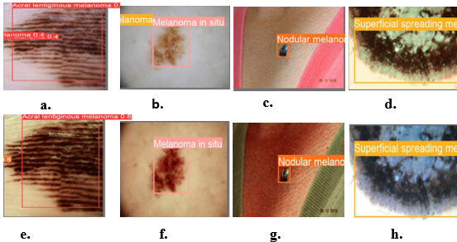
Fig. 4. 1 The prediction results of skin cancer in this study, (a, e) Acral Lentiginous melanoma WLI and SAVE respectively, (b, f) Melanoma in Situ WLI and SAVE, (c, g) Nodular melanoma WLI and SAVE, (d, h) Superficial Spreading melanoma WLI and SAVE respectively.

High performance is underlined by its high mAP score, which is indicative of better overall prediction accuracy across multiple threshold settings. In contrast, the YOLOv8-SAVE model has superior precision at above 90%, coupled with a lower recall of 71%, indicating it is highly accurate in its detection of true positives but misses many actual positives. This is further put into perspective when compared to the performance of the Yolov8 WLI model, whose precision and recall are more balanced at 84.3% and 75.5%, respectively. This discrepancy suggests that the YOLOv8 model, as configured for the SAVE model, does not balance accuracy and coverage but favours the former at the expense of the latter, possibly overlooking some true positive cases in favor of maintaining high confidence levels in the cases it actually detected. This imbalance, particularly lower recall, can be changed with adjustments such as through the modification of the decision threshold, improvement of feature selection, or enriching the training data with examples that span more of the range of diversity. These changes might help the model pick up on more subtle features.

Table 4. 1 Performance result analysis for various ML Models
Framework | Model | Precision | Recall | F1-Score | mAP
YOLOv5 | WLI | 0.804 | 0.707 | 0.751 | 0.797
YOLOv5 | SAVE | 0.799 | 0.829 | 0.810 | 0.819
YOLOv8 | WLI | 0.843 | 0.755 | 0.795 | 0.807
YOLOv8 | SAVE | 0.904 | 0.71 | 0.794 | 0.801
YOLOv9 | WLI | 0.806 | 0.605 | 0.65 | 0.737
YOLOv9 | SAVE | 0.783 | 0.666 | 0.71 | 0.775
YOLO-NAS | WLI | 0.733 | 0.541 | 0.623 | 0.659
YOLO-NAS | SAVE | 0.731 | 0.665 | 0.69 | 0.69
Roboflow3.0 | WLI | 0.719 | 0.643 | 0.675 | 0.66
Roboflow3.0 | SAVE | 0.781 | 0.613 | 0.68 | 0.68

As concerns on the precision, ALM and NM showed high accuracy on the SAVE model to both of YOLOv5 and YOLOv8 models whereas MIS and SSM reached to different conclusions as there is a decrease almost by 23% and 7% changes with the YOLOv5-SAVE model and by 18% and 1% with YOLOv8 for both of MIS-Save and SSM-Save model to be more precise. On recall alone across the two machine learning architectures, WLI either outperformed SAVE or ended up with a similar result, except for two cases where SAVE outperformed the WLI model. Results for YOLOv9 were very different, with Acral lentiginous melanoma reaching the lowest precision of 65.7% in the WLI model and improved by 29% in the SAVE model, while Melanoma in situ had a higher precision of 94.9% in the WLI model, which went down to 79.8% in the SAVE model. The recall values are, however, less compared to precision with the other models. However, the average mAP50 was found to be above in the YOLOv9 model than in all of the other models. This presented an extraordinarily high accuracy rate by the model in learning lesion features. The accuracy rates of both the WLI model and the SAVE model appear very similar, which may be due to the number of images used for this relatively smaller study.
This study has, shown that SAVE-based conversion algorithms that can change WLI images into SAVE images have the potential to accurately classify and detect skin cancer. With most of the detections stable. The convergence of loss functions for the training set of YOLOv5 WLI is represented in the Fig. A.1. The YOLOv5 WLI results shown in Fig.A.2 for confusion matrix, precision, F1-confidence, precision-confidence, and recall. The convergence of loss functions for the training set of YOLOv5 SAVE is represented in the Fig. A.3. The YOLOv5 SAVE results shown in Fig.A.4 for confusion matrix, precision, F1-confidence, precision-confidence, and recall. The convergence of loss functions for the training set of YOLOv8 WLI is represented in the Fig. A.5. The YOLOv8 WLI results shown in Fig.A.6 for confusion matrix, precision, F1-confidence, precision-confidence, and recall. The YOLOv8 convergence of loss functions results for a training set of SAVE images and precision, recall, and average precision are shown in Fig.A.7. The YOLOv8 SAVE results for confusion matrix, precision, recall, F1-confidence, and precision-confidence is shown in Fig.A.8. The YOLOv9 convergence of loss functions results for a training set of WLI images and precision, recall, and average precision are shown in Fig.A.9. The YOLOv9 WLI results shown in Fig.A.10 for confusion matrix, precision, F1-confidence, precision-confidence, and recall. The YOLOv9 convergence of loss functions results for a training set of SAVE images and precision, recall, and average precision are shown in Fig.A.11.

.
Architecture | Model | Classification | Precision | Recall | mAP50 | mAP50-95 | Accuracy
YOLOv5 | WLI | ALM | 0.865 | 0.875 | 0.966 | 0.6 | 0.98
YOLOv5 | WLI | M in Situ | 0.78 | 0.545 | 0.597 | 0.323 | 0.98
YOLOv5 | WLI | NM | 0.732 | 0.9 | 0.932 | 0.679 | 0.98
YOLOv5 | WLI | SSM | 0.784 | 0.542 | 0.612 | 0.33 | 0.98
YOLOv5 | SAVE | ALM | 0.919 | 0.812 | 0.903 | 0.551 | 0.96
YOLOv5 | SAVE | M in Situ | 0.551 | 0.455 | 0.481 | 0.223 | 0.96
YOLOv5 | SAVE | NM | 0.84 | 0.8 | 0.842 | 0.60 | 0.96
YOLOv5 | SAVE | SSM | 0.669 | 0.625 | 0.598 | 0.299 | 0.96
YOLOv8 | WLI | ALM | 0.938 | 0.95 | 0.965 | 0.562 | 0.96
YOLOv8 | WLI | M in Situ | 0.685 | 0.545 | 0.608 | 0.294 | 0.96
YOLOv8 | WLI | NM | 0.867 | 0.9 | 0.932 | 0.62 | 0.96
YOLOv8 | WLI | SSM | 0.882 | 0.623 | 0.725 | 0.419 | 0.96
YOLOv8 | SAVE | ALM | 0.946 | 0.812 | 0.957 | 0.55 | 0.98
YOLOv8 | SAVE | M in Situ | 0.859 | 0.555 | 0.7 | 0.286 | 0.98
YOLOv8 | SAVE | NM | 0.851 | 0.9 | 0.891 | 0.631 | 0.98
YOLOv8 | SAVE | SSM | 0.875 | 0.582 | 0.639 | 0.338 | 0.98
YOLOv9 | WLI | ALM | 0.657 | 0.846 | 0.814 | 0.508 | 0.83
YOLOv9 | WLI | M in Situ | 0.949 | 0.667 | 0.826 | 0.46 | 0.83
YOLOv9 | WLI | NM | 0.882 | 0.231 | 0.533 | 0.33 | 0.83
YOLOv9 | WLI | SSM | 0.737 | 0.676 | 0.776 | 0.472 | 0.83
YOLOv9 | SAVE | ALM | 0.849 | 1 | 0.995 | 0.4 | 0.87
YOLOv9 | SAVE | M in Situ | 0.798 | 0.607 | 0.749 | 0.45 | 0.87
YOLOv9 | SAVE | NM | 0.755 | 0.571 | 0.765 | 0.416 | 0.87
YOLOv9 | SAVE | SSM | 0.73 | 0.484 | 0.579 | 0.31 | 0.87
Table 4. 2 Evaluation analysis of various skin cancer categories

ALM = Acral Lentiginous melanoma
M in Situ = Melanoma in Situ
NM = Nodular melanoma
SSM = Superficial Spreading melanoma

The YOLOv9 SAVE results shown in Fig.A.12 for confusion matrix, precision, F1-confidence, precision-confidence, and recall. The YOLO-NAS convergence of loss functions results for a training set of WLI images and precision, recall, and average precision are shown in Fig.A.13.
The YOLO-NAS WLI training results for precision, box loss, class loss, and object loss shown in Fig. A.14. The YOLO-NAS convergence of loss functions results for a training set of SAVE images and precision, recall, and average precision are shown in Fig.A.15. The YOLO-NAS SAVE training results for precision, box loss, class loss, and object loss shown in Fig. A.16. The convergence of loss functions results for a training set of WLI images of ROBOFLOW3.0 and precision, recall, and average precision are shown in Fig.A.17. The ROBOFLOW3.0 WLI training results for precision, box loss, class loss, and object loss shown in Fig. A.18. The convergence of loss functions results for a training set of SAVE images of ROBOFLOW3.0 and precision, recall, and average precision are shown in Fig.A.19. The ROBOFLOW3.0 SAVE training results for precision, box loss, class loss, and object loss shown in Fig. A.20.
The confusion matrix results represent the prediction summary of how many lesions are correct and incorrect according to the class. The following Fig.4.2, and Fig.4.3 are the YOLOv5 confusion matrix results of WLI, SAVE respectively. The prediction results of YOLOv8 confusion matrix for WLI, and SAVE represented in Fig.4.4, Fig.4.5. The following Fig.4.6, and Fig.4.7 are the YOLOv9 confusion matrix results of WLI, SAVE respectively.

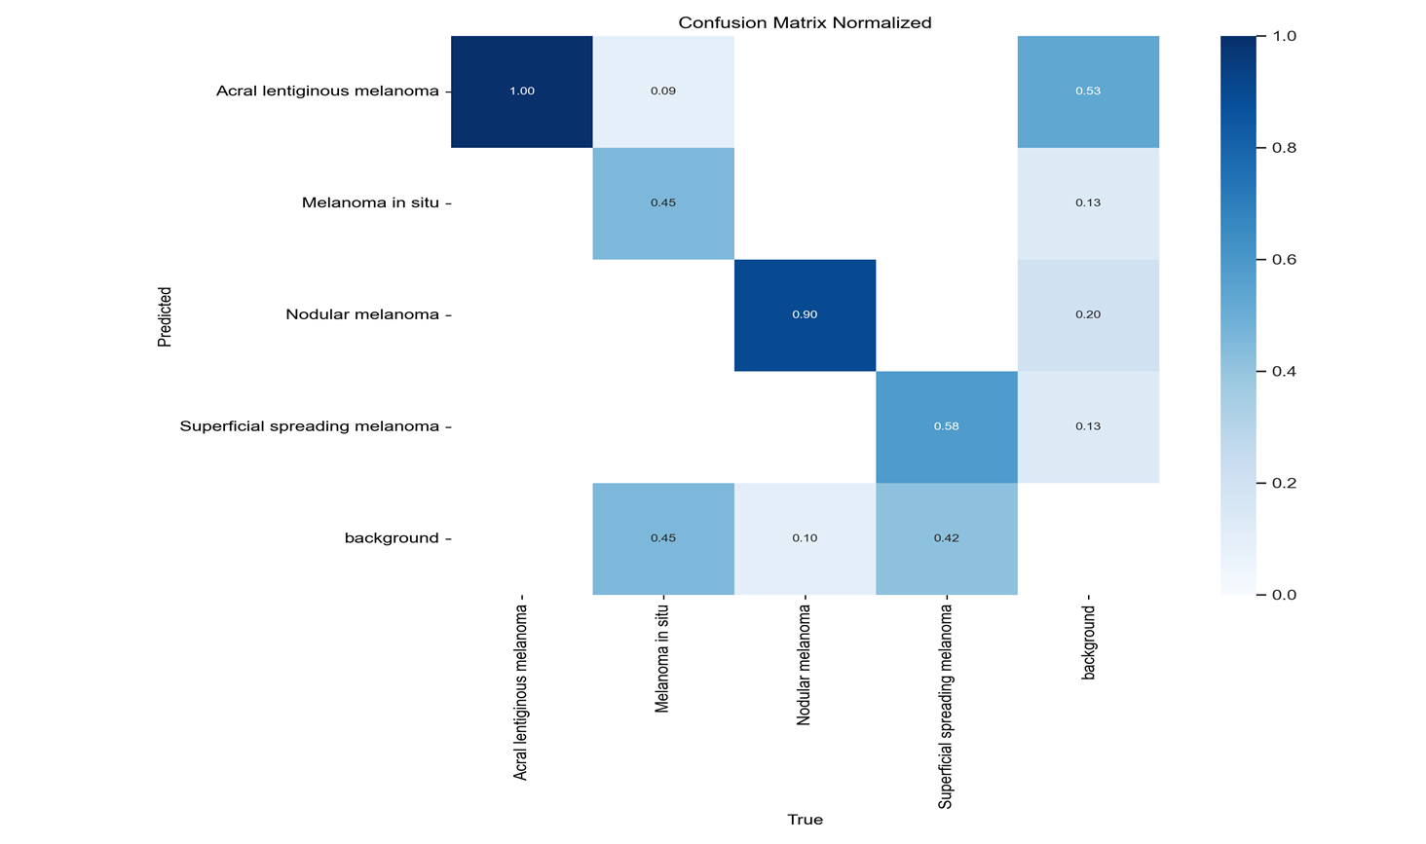
Fig. 4. 2 YOLOv5 White Light Imaging (WLI) confusion matrix results

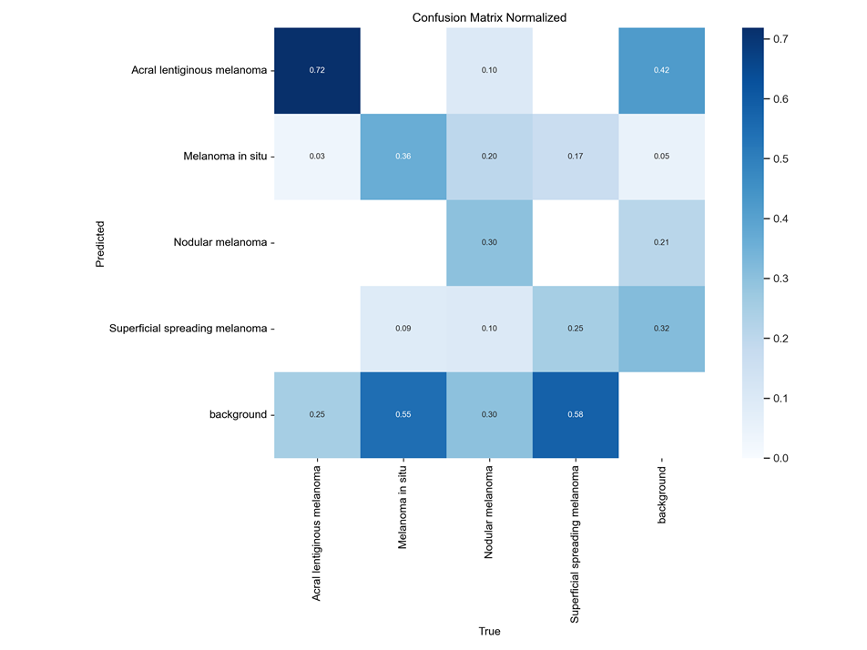

Fig. 4. 3 YOLOv5 Spectrum Aided Visual Enhancer (SAVE) confusion matrix results

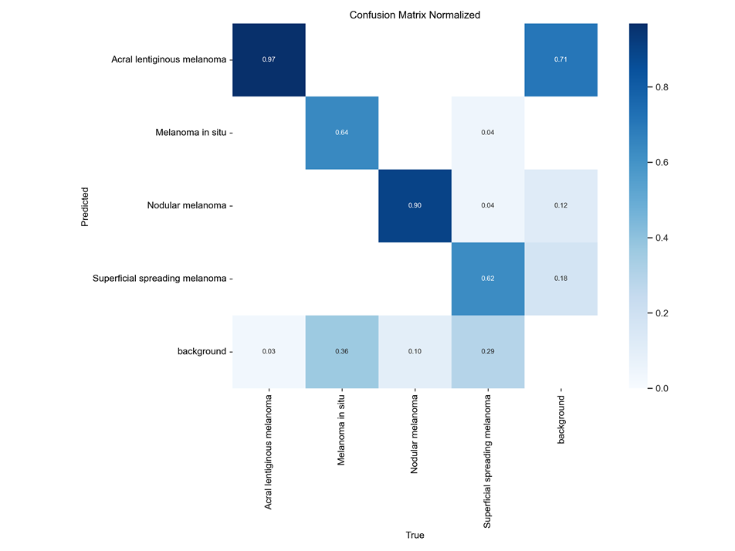

Fig. 4. 4 YOLOv8 White Light Imaging (WLI) confusion matrix results

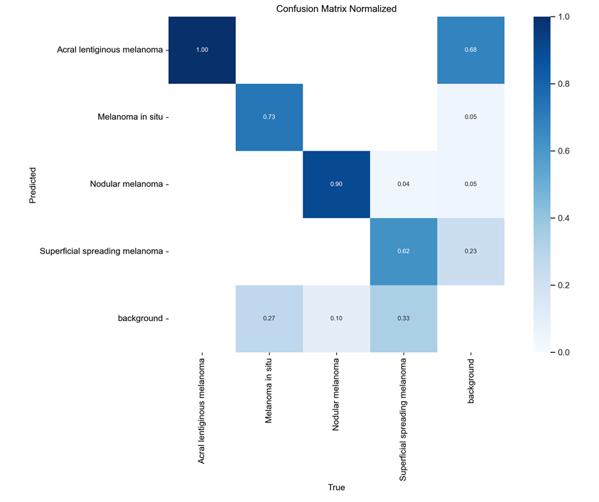

Fig. 4. 5 YOLOv8 Spectrum-Aided Visual Enhancer (SAVE) confusion matrix results

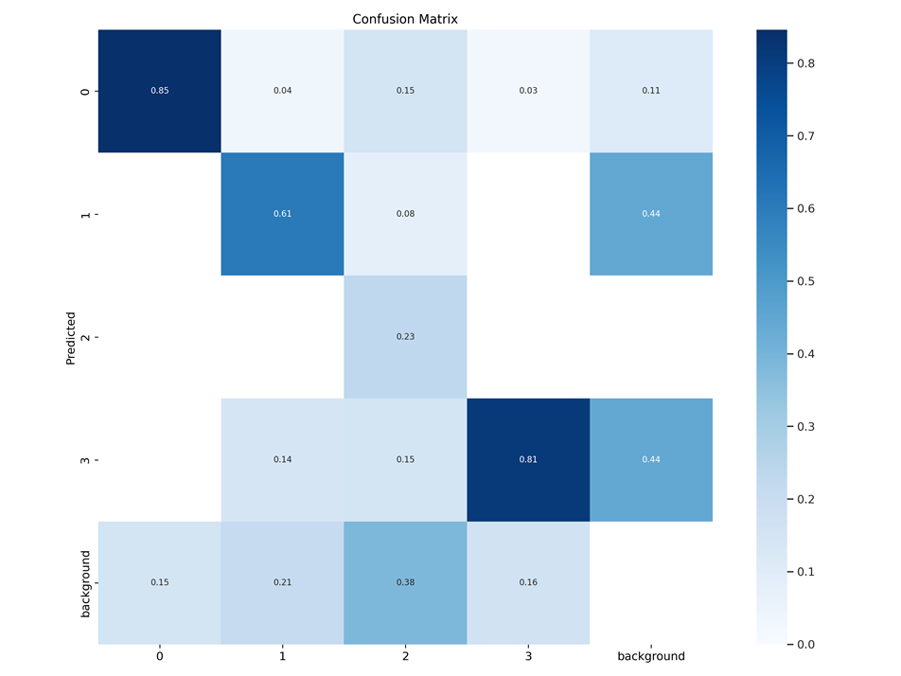

Fig. 4. 6 YOLOv9 White Light Imaging (WLI) confusion matrix results

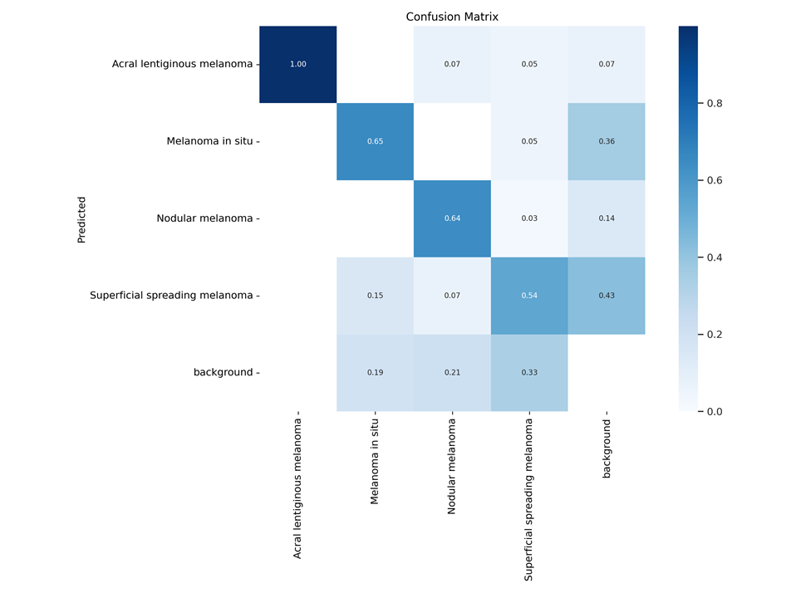

Fig. 4. 7 YOLOv9 Spectrum-Aided Visual Enhancer (SAVE) confusion matrix results

CONCLUSIONS
Skin cancer cases have been reported to be growing over the past decades. Despite being diagnosed by an expert dermatologist, the cases are still veritably gruelling because of the colourful appearances and symptoms. Lately, deep learning models have displayed significant performance improvements in medical diagnostics, particularly in skin cancer identification. This research presents four types of skin cancer groups using a pre-trained convolutional neural network to achieve accurate findings. To analyse skin lesions from images we used WLI and SAVE datasets, a combination of clinical photos and ISIC categories to detect melanoma. Yolo-based deep neural network method is proposed for classifying and detecting four types of skin diseases, namely, Acral lentiginous melanoma, Melanoma in situ, Nodular melanoma and Superficial spreading melanoma. The SAVE classification model shows a superior detection effect compared to the original WLI image. By utilizing the SAVE dataset, the average precision is 0.919%, 0.946%, 0.849%, 0.69%, and 0.68% separately Yolov5, Yolov8, Yolov9, Yolo-Nas, and Roboflow3.0 on a dataset of 878 pictures. Based on the experimental analysis, it is evident that Yolov5, Yolov8, and Yolov9 are the most suitable for classifying and detecting melanoma. Yolov8 outperforms Yolov5 and Yolov9 in most cases. Yolov8 has demonstrated its superiority by achieving the highest scores in all evaluation metrics compared to conventional methods. As far as we know, there has been no previous research on the ISIC dataset attempting to classify four types of skin cancer. In the future, incorporating larger datasets for each type of cancer will improve the results of the proposed work, aiding better clinical investigation. Even the present project will also be tested with the latest Yolov9 version to achieve the best classification results.

FUTURE SCOPE
This research's main objective is to analyse clinical photos of skin cancer using a deep neural network called YOLO. Future skin lesion diagnosis accuracy could be improved in a number of ways, including Getting more skin lesion images with annotations and expanding the dataset size will help the YOLO model be better trained. Collective Education Enhancing detection performance and lowering mistakes can be achieved by combining predictions from several YOLO models or by merging YOLO with other deep learning models to form an ensemble method. cooperation with professionals in computer vision, machine learning, and dermatology to solve challenging problems and improve the model's performance.

The demands of the medical diagnostic work may influence the model selection. For example, a greater recall model such as YOLOv5 may be better in situations where failing to diagnose a patient could have serious consequences. Conversely, YOLOv8 would be a fantastic option in circumstances where accuracy is essential to prevent needless therapies. As a result, choosing the best model requires balancing these parameters in a way that is specific to the requirements of the medical application. In addition to highlighting each model's advantages and disadvantages, this analysis provides a roadmap for improving these instruments' diagnostic precision in medical imaging. The possible lack of generalizability results from the particular dataset utilized in this study, which may not accurately reflect the varied range of skin types and cancer stages.

Furthermore, the research concentrated on performance measures like recall and precision, thereby ignoring qualitative elements like clinical usability and model interpretability. It's possible that the models' performance in controlled experimental conditions was not entirely representative of real-world clinical circumstances. Finally, the high computational requirements of these sophisticated models may prevent them from being used practically in environments with limited resources, requiring additional optimization for wider applicability. Future work will aim to enrich the dataset with a greater variety of skin types, diseases and cancer grades to enhance the model's broad-spectrum potentialities as related herein. This might include qualitative evaluations, including from physicians' comments that would facilitate utilization and interpretation of these models in real-life applications. Additionally, making models lighter or using newer more efficient machine learning frameworks could lower the computing needs and eventually bring this technology in environments with limited resources. Real-world challenges and user needs can be explored from the pilot version testing with clinical partners as well. This research presents costly and hopeful future directions to explore the SAVE algorithm for skin cancer diagnosis by extending it through numerous YOLO models in a modern Roboflow 3.0 framework.

Given the early results, future studies may explore alternative mechanisms to enhance precision and applicability of these models. Second, a more general value of ensembles in the SAVE algorithm could be made available when it is encapsulated using advanced machine learning techniques such as deep learning ensemble strategies to improve precision and recall thereby leading into better diagnostics. Further testing other imaging modalities in conjunction with hyperspectral imaging may increase the durability of diagnostics as well as improve model validation and training datasets. Additionally, depending on the model for clinical models in real-world applications as part of standard skin cancer screening should provide invaluable feedback related to their user-friendliness and operational behaviour. One important thing which will be needed is to make the dataset larger including more of other skin diseases and different stages of cancer.

REFERENCES

1. Z. Khazaei et al., Global incidence and mortality of skin cancer by histological subtype and its relationship with the human development index (HDI); an ecology study in 2018. World times Cancer Res J 6, e13 (2019).
2. T. L. Diepgen, V. Mahler, The epidemiology of skin cancer. British Journal of Dermatology 146, 1-6 (2002).
3. V. Mittal et al., Association between non‐melanoma skin cancer and risk of fractures. Skin Health and Disease 4, (2024).
4. S. Hoey et al., Skin cancer trends in Northern Ireland and consequences for provision of dermatology services. British Journal of Dermatology 156, 1301-1307 (2007).
5. D. Schadendorf et al., Melanoma. The Lancet 392, 971-984 (2018).
6. A. N. Houghton, D. Polsky, Focus on melanoma. Cancer cell 2, 275-278 (2002).
7. V. Madan, J. T. Lear, R.-M. Szeimies, Non-melanoma skin cancer. The lancet 375, 673-685 (2010).
8. T. Karnakis et al., The role of geriatric oncology in the care of older people with cancer: some evidence from Brazil and the world. Revista da Associação Médica Brasileira 70, e2024S2118 (2024).
9. R. L. Siegel, A. N. Giaquinto, A. Jemal, Cancer statistics, 2024. CA: a cancer journal for clinicians 74, (2024).
10. A.-M. Forsea, V. Del Marmol, E. De Vries, E. Bailey, A. Geller, Melanoma incidence and mortality in Europe: new estimates, persistent disparities. British journal of dermatology 167, 1124-1130 (2012).
11. C. Karimkhani et al., The global burden of melanoma: results from the Global Burden of Disease Study 2015. British Journal of Dermatology 177, 134-140 (2017).
12. C. Barata, M. Ruela, M. Francisco, T. Mendonça, J. S. Marques, Two systems for the detection of melanomas in dermoscopy images using texture and color features. IEEE systems Journal 8, 965-979 (2013).
13. D. E. Godar, Worldwide increasing incidences of cutaneous malignant melanoma. Journal of skin cancer 2011, 858425 (2011).
14. C. Smittenaar, K. Petersen, K. Stewart, N. Moitt, Cancer incidence and mortality projections in the UK until 2035. British journal of cancer 115, 1147-1155 (2016).
15. M. R. Donaldson, B. M. Coldiron, in Seminars in cutaneous medicine and surgery. (WB Saunders, 2011), vol. 30, pp. 3-5.
16. H. Sung et al., Global cancer statistics 2020: GLOBOCAN estimates of incidence and mortality worldwide for 36 cancers in 185 countries. CA: a cancer journal for clinicians 71, 209-249 (2021).
17. J. Ferlay et al., Cancer incidence and mortality worldwide: sources, methods and major patterns in GLOBOCAN 2012. International journal of cancer 136, E359-E386 (2015).
18. D. Wen et al., Characteristics of publicly available skin cancer image datasets: a systematic review. The Lancet Digital Health 4, e64-e74 (2022).
19. M. A. Al-Masni, M. A. Al-Antari, M.-T. Choi, S.-M. Han, T.-S. Kim, Skin lesion segmentation in dermoscopy images via deep full resolution convolutional networks. Computer methods and programs in biomedicine 162, 221-231 (2018).
20. C. M. Balch et al., Final version of 2009 AJCC melanoma staging and classification. Journal of clinical oncology 27, 6199-6206 (2009).
21. T. J. Brinker et al., Skin cancer classification using convolutional neural networks: systematic review. Journal of medical Internet research 20, e11936 (2018).
22. A. Marka, J. B. Carter, E. Toto, S. Hassanpour, Automated detection of nonmelanoma skin cancer using digital images: a systematic review. BMC medical imaging 19, 1-12 (2019).
23. D. Adla, G. V. R. Reddy, P. Nayak, G. Karuna, Deep learning-based computer aided diagnosis model for skin cancer detection and classification. Distributed and Parallel Databases 40, 717-736 (2022).
24. E. L. Henriksen, J. F. Carlsen, I. M. Vejborg, M. B. Nielsen, C. A. Lauridsen, The efficacy of using computer-aided detection (CAD) for detection of breast cancer in mammography screening: a systematic review. Acta radiologica 60, 13-18 (2019).
25. L. Ferrante di Ruffano et al., Computer‐assisted diagnosis techniques (dermoscopy and spectroscopy‐based) for diagnosing skin cancer in adults. Cochrane Database of Systematic Reviews 2018, (1996).
26. Y.-J. Fang, A. Mukundan, Y.-M. Tsao, C.-W. Huang, H.-C. Wang, Identification of early esophageal cancer by semantic segmentation. Journal of Personalized Medicine 12, 1204 (2022).
27. R. B. Oliveira et al., Computational methods for the image segmentation of pigmented skin lesions: a review. Computer methods and programs in biomedicine 131, 127-141 (2016).
28. V. Du Le, Q. Wang, T. Gould, J. C. Ramella-Roman, T. J. Pfefer, Vascular contrast in narrow-band and white light imaging. Applied Optics 53, 4061-4071 (2014).
29. T.-J. Tsai et al., Intelligent identification of early esophageal cancer by band-selective hyperspectral imaging. Cancers 14, 4292 (2022).
30. L. Lixin, L. Mengzhu, Z. Zhigang, Q. Junle, Recent advances of hyperspectral imaging application in biomedicine. Chinese Journal of Lasers 45, 0207017 (2018).
31. J. Yoon, Hyperspectral imaging for clinical applications. BioChip Journal 16, 1-12 (2022).
32. Y. Zhang et al., Applications of hyperspectral imaging in the detection and diagnosis of solid tumors. Translational Cancer Research 9, 1265 (2020).
33. M. H. F. Butt et al., Intelligent tumor tissue classification for Hybrid Health Care Units. Frontiers in Medicine 11, 1385524 (2024).
34. S. Barbeiro, D. Libânio, R. Castro, M. Dinis-Ribeiro, P. Pimentel-Nunes, Narrow-band imaging: clinical application in gastrointestinal endoscopy. GE-Portuguese Journal of Gastroenterology 26, 40-53 (2018).
35. S. C. Kefauver, J. Peñuelas, S. L. Ustin, in 2012 IEEE International Geoscience and Remote Sensing Symposium. (IEEE, 2012), pp. 3379-3382.
36. P. Iyer, A. Sriram, S. Lal, Deep learning ensemble method for classification of satellite hyperspectral images. Remote Sensing Applications: Society and Environment 23, 100580 (2021).
37. S.-E. Qian, Hyperspectral satellites, evolution, and development history. IEEE Journal of Selected Topics in Applied Earth Observations and Remote Sensing 14, 7032-7056 (2021).
38. S. Wang et al., Cross-scale sensing of field-level crop residue cover: Integrating field photos, airborne hyperspectral imaging, and satellite data. Remote Sensing of Environment 285, 113366 (2023).
39. S. Peyghambari, Y. Zhang, Hyperspectral remote sensing in lithological mapping, mineral exploration, and environmental geology: an updated review. Journal of Applied Remote Sensing 15, 031501-031501 (2021).
40. D. Ramakrishnan, R. Bharti, Hyperspectral remote sensing and geological applications. Current science, 879-891 (2015).
41. T. Kurz, S. Buckley, J. Becker, in Proceedings of the World Tunnel Congress. (2017), pp. 10.
42. A. Mukundan, Y.-M. Tsao, H.-C. Wang, in Holography, Diffractive Optics, and Applications XIII. (SPIE, 2023), vol. 12768, pp. 17-25.
43. M. Shimoni, R. Haelterman, C. Perneel, Hypersectral imaging for military and security applications: Combining myriad processing and sensing techniques. IEEE Geoscience and Remote Sensing Magazine 7, 101-117 (2019).
44. C. Ke, in 2017 International Conference on Progress in Informatics and Computing (PIC). (IEEE, 2017), pp. 124-128.
45. B. Lu, P. D. Dao, J. Liu, Y. He, J. Shang, Recent advances of hyperspectral imaging technology and applications in agriculture. Remote Sensing 12, 2659 (2020).
46. T. Adão et al., Hyperspectral imaging: A review on UAV-based sensors, data processing and applications for agriculture and forestry. Remote sensing 9, 1110 (2017).
47. I.-C. Wu et al., Early identification of esophageal squamous neoplasm by hyperspectral endoscopic imaging. Scientific reports 8, 13797 (2018).
48. A. Mukundan, C.-C. Huang, T.-C. Men, F.-C. Lin, H.-C. Wang, Air pollution detection using a novel snap-shot hyperspectral imaging technique. Sensors 22, 6231 (2022).
49. C.-L. Tsai et al., Hyperspectral imaging combined with artificial intelligence in the early detection of esophageal cancer. Cancers 13, 4593 (2021).
50. R. Qureshi et al., A comprehensive systematic review of yolo for medical object detection (2018 to 2023). Authorea Preprints, (2023).
51. I. Gkouzionis et al., A YOLOv5-based network for the detection of a diffuse reflectance spectroscopy probe to aid surgical guidance in gastrointestinal cancer surgery. International Journal of Computer Assisted Radiology and Surgery 19, 11-14 (2024).
52. N. Aishwarya, K. M. Prabhakaran, F. T. Debebe, M. S. S. A. Reddy, P. Pranavee, Skin cancer diagnosis with YOLO deep neural network. Procedia Computer Science 220, 651-658 (2023).
53. F. Prinzi, M. Insalaco, A. Orlando, S. Gaglio, S. Vitabile, A yolo-based model for breast cancer detection in mammograms. Cognitive Computation 16, 107-120 (2024).
54. S. Tamang, B. Sen, A. Pradhan, K. Sharma, V. K. Singh, Enhancing covid-19 safety: Exploring yolov8 object detection for accurate face mask classification. International Journal of Intelligent Systems and Applications in Engineering 11, 892-897 (2023).
55. H. A. Haenssle et al., Man against machine reloaded: performance of a market-approved convolutional neural network in classifying a broad spectrum of skin lesions in comparison with 96 dermatologists working under less artificial conditions. Annals of oncology 31, 137-143 (2020).
56. H.-Y. Huang et al., Classification of skin cancer using novel hyperspectral imaging engineering via YOLOv5. Journal of Clinical Medicine 12, 1134 (2023).
57. E. Goceri, in 2021 44th international conference on telecommunications and signal processing (TSP). (IEEE, 2021), pp. 48-51.
58. R. Leon et al., Non-invasive skin cancer diagnosis using hyperspectral imaging for in-situ clinical support. Journal of clinical medicine 9, 1662 (2020).
59. H.-Y. Huang et al., Identification of skin lesions by snapshot hyperspectral imaging. Cancers 16, 217 (2024).
60. N. Aburaed et al., in Artificial Intelligence for Medicine. (Elsevier, 2024), pp. 133-149.
61. R. Nersisson, T. J. Iyer, A. N. Joseph Raj, V. Rajangam, A dermoscopic skin lesion classification technique using YOLO-CNN and traditional feature model. Arabian Journal for Science and Engineering 46, 9797-9808 (2021).
62. Y. Nie, P. Sommella, M. O’Nils, C. Liguori, J. Lundgren, in 2019 E-Health and Bioengineering Conference (EHB). (IEEE, 2019), pp. 1-4.
63. H. M. Ünver, E. Ayan, Skin lesion segmentation in dermoscopic images with combination of YOLO and grabcut algorithm. Diagnostics 9, 72 (2019).
64. W. Gouda, N. U. Sama, G. Al-Waakid, M. Humayun, N. Z. Jhanjhi, in Healthcare. (MDPI, 2022), vol. 10, pp. 1183.
65. M. Qi, Y. Liu, Y. Li, L. Liu, Z. Zhang, in SPIE-CLP Conference on Advanced Photonics 2022. (SPIE, 2023), vol. 12601, pp. 7-11.
66. N. A. AlSadhan, S. A. Alamri, M. M. Ben Ismail, O. Bchir, Skin Cancer Recognition Using Unified Deep Convolutional Neural Networks. Cancers 16, 1246 (2024).
67. S. N. Markovic et al., in Mayo Clinic Proceedings. (Elsevier, 2007), vol. 82, pp. 364-380.
68. O. Dodge, New Concepts in Surgical Pathology of the Skin. British Journal of Cancer 34, 579 (1976).
69. V. L. Gordon-Dseagu, S. S. Devesa, M. Goggins, R. Stolzenberg-Solomon, Pancreatic cancer incidence trends: evidence from the Surveillance, Epidemiology and End Results (SEER) population-based data. International journal of epidemiology 47, 427-439 (2018).
70. P. T. Bradford, A. M. Goldstein, M. L. McMaster, M. A. Tucker, Acral lentiginous melanoma: incidence and survival patterns in the United States, 1986-2005. Archives of dermatology 145, 427-434 (2009).
71. D. M. Bello et al., Prognosis of acral melanoma: a series of 281 patients. Annals of surgical oncology 20, 3618-3625 (2013).
72. Y. Teramoto et al., Acral lentiginous melanoma: a skin cancer with unfavourable prognostic features. A study of the German central malignant melanoma registry (CMMR) in 2050 patients. Br J Dermatol 178, 443-451 (2018).
73. D. M. Holman, J. B. King, A. White, S. D. Singh, J. L. Lichtenfeld, Acral lentiginous melanoma incidence by sex, race, ethnicity, and stage in the United States, 2010–2019. Preventive Medicine 175, 107692 (2023).
74. M. S. Tsai, M. W. Chiu, Patient-reported frequency of acral surface inspection during skin examination in white and ethnic minority patients. Journal of the American Academy of Dermatology 71, 249-255 (2014).
75. Y. Nakamura, Y. Fujisawa, Diagnosis and management of acral lentiginous melanoma. Current treatment options in oncology 19, 1-11 (2018).
76. C. C. Darmawan et al., Early detection of acral melanoma: a review of clinical, dermoscopic, histopathologic, and molecular characteristics. Journal of the American Academy of Dermatology 81, 805-812 (2019).
77. V. Nikolaou, A. Stratigos, Emerging trends in the epidemiology of melanoma. British journal of dermatology 170, 11-19 (2014).
78. L. Wang, J. Wu, Z. Dai, S. Ji, R. Jiang, Clinical characteristics and prognosis of acral lentiginous melanoma: a single-center series of 211 cases in China. Int J Dermatol 60, 1504-1509 (2021).
79. C. Garbe, U. Leiter, Melanoma epidemiology and trends. Clinics in dermatology 27, 3-9 (2009).
80. K. G. Paulson et al., Age-specific incidence of melanoma in the United States. JAMA dermatology 156, 57-64 (2020).
81. A.-V. Giblin, J. Thomas, Incidence, mortality and survival in cutaneous melanoma. Journal of plastic, reconstructive & aesthetic surgery 60, 32-40 (2007).
82. R. L. Siegel, K. D. Miller, A. Jemal, Cancer statistics, 2019. CA: a cancer journal for clinicians 69, 7-34 (2019).
83. E. Linos, S. M. Swetter, M. G. Cockburn, G. A. Colditz, C. A. Clarke, Increasing burden of melanoma in the United States. Journal of investigative dermatology 129, 1666-1674 (2009).
84. K. C. Lee, M. A. Weinstock, Melanoma is up: are we up to this challenge? Journal of Investigative Dermatology 129, 1604-1606 (2009).
85. H. G. Welch, S. Woloshin, L. M. Schwartz, Skin biopsy rates and incidence of melanoma: population based ecological study. Bmj 331, 481 (2005).
86. A. Balamurugan et al., Subsequent primary cancers among men and women with in situ and invasive melanoma of the skin. Journal of the American Academy of Dermatology 65, S69. e61-S69. e69 (2011).
87. A. B. Francken, H. M. Shaw, J. F. Thompson, Detection of second primary cutaneous melanomas. European Journal of Surgical Oncology (EJSO) 34, 587-592 (2008).
88. K. A. McCaul, L. Fritschi, P. Baade, M. Coory, The incidence of second primary invasive melanoma in Queensland, 1982–2003. Cancer Causes & Control 19, 451-458 (2008).
89. M. Coory et al., Trends for in situ and invasive melanoma in Queensland, Australia, 1982–2002. Cancer Causes & Control 17, 21-27 (2006).
90. A. Green et al., Daily sunscreen application and betacarotene supplementation in prevention of basal-cell and squamous-cell carcinomas of the skin: a randomised controlled trial. The Lancet 354, 723-729 (1999).
91. W. R. Stanton, M. Janda, P. D. Baade, P. Anderson, Primary prevention of skin cancer: a review of sun protection in Australia and internationally. Health promotion international 19, 369-378 (2004).
92. T. K. Lee, J. K. Rivers, R. P. Gallagher, Site-specific protective effect of broad-spectrum sunscreen on nevus development among white schoolchildren in a randomized trial. Journal of the American Academy of Dermatology 52, 786-792 (2005).
93. M. Huncharek, B. Kupelnick, Use of topical sunscreens and the risk of malignant melanoma: a meta-analysis of 9067 patients from 11 case–control studies. American journal of public health 92, 1173-1177 (2002).
94. C. Bartoli et al., Clinical diagnosis and therapy of cutaneous melanoma in situ. Cancer: Interdisciplinary International Journal of the American Cancer Society 77, 888-892 (1996).
95. S. W. Menzies et al., Dermoscopic evaluation of nodular melanoma. JAMA dermatology 149, 699-709 (2013).
96. D. S. Rigel, in Seminars in cutaneous medicine and surgery. (WB Saunders, 2010), vol. 29, pp. 204-209.
97. L. J. Gardner, J. L. Strunck, Y. P. Wu, D. Grossman, Current controversies in early-stage melanoma: questions on incidence, screening, and histologic regression. Journal of the American Academy of Dermatology 80, 1-12 (2019).
98. P. Singh, H. J. Kim, R. A. Schwartz, Superficial spreading melanoma: an analysis of 97 702 cases using the SEER database. Melanoma research 26, 395-400 (2016).
99. H. Li, S. Zhuang, D.-a. Li, J. Zhao, Y. Ma, Benign and malignant classification of mammogram images based on deep learning. Biomedical Signal Processing and Control 51, 347-354 (2019).
100. H.-J. Rong, Y.-S. Ong, A.-H. Tan, Z. Zhu, A fast pruned-extreme learning machine for classification problem. Neurocomputing 72, 359-366 (2008).

APPENDIX A

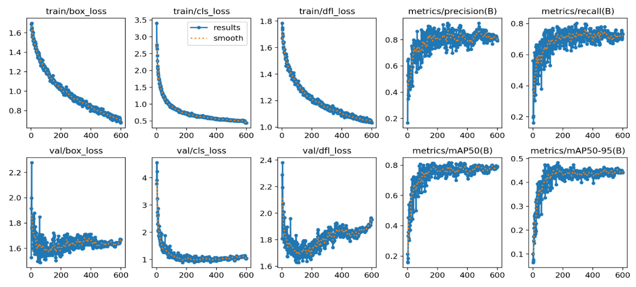
Fig. A. 1 YOLOv5 Convergence of loss functions for a training set of WLI images and precision, recall, and average precision

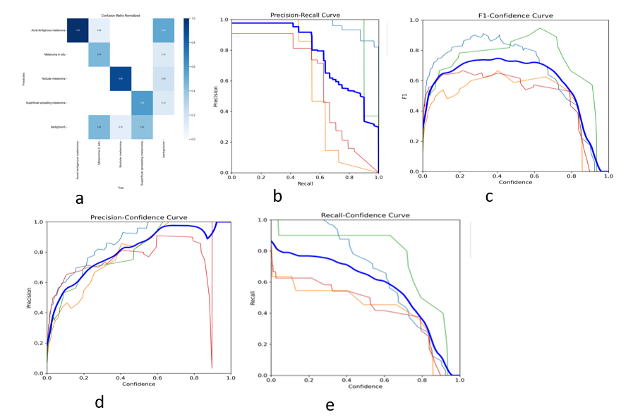
Fig. A. 2 YOLOv5 WLI results from a. confusion matrix, b. precision, c. F1-confidence, d. precision-confidence, e. recall
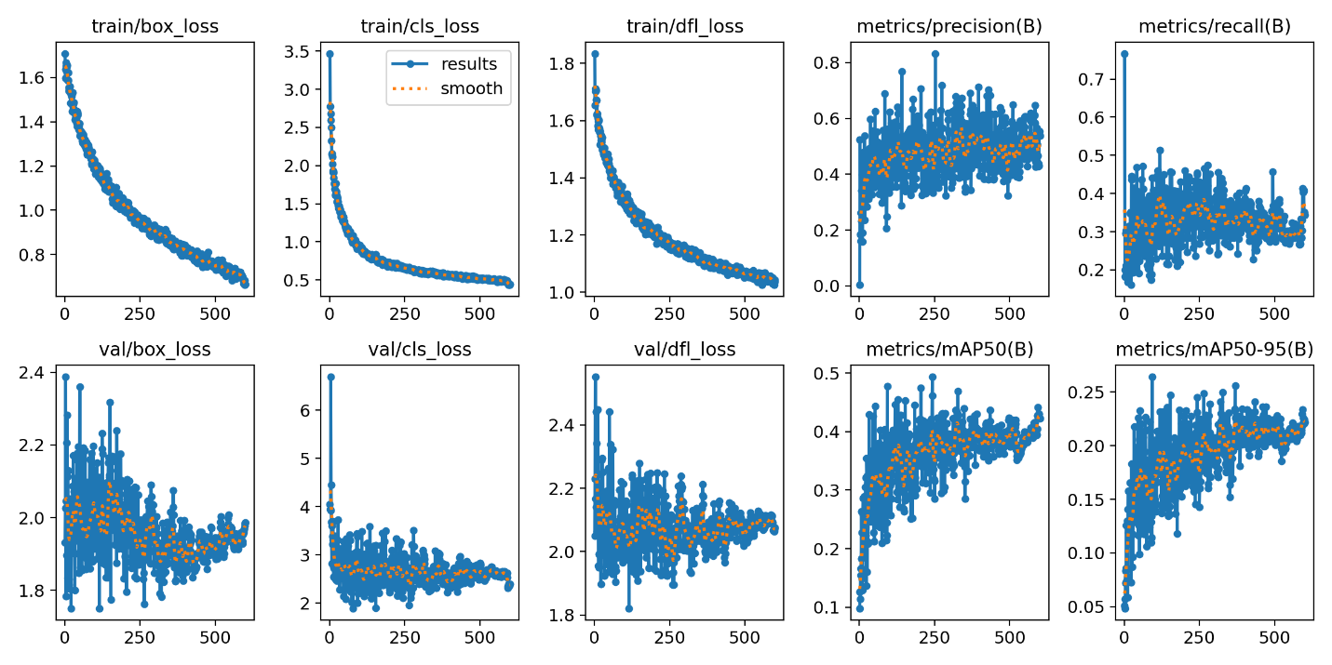
Fig. A. 3 YOLOv5 Convergence of loss functions for a training set of SAVE images and precision, recall, and average precision
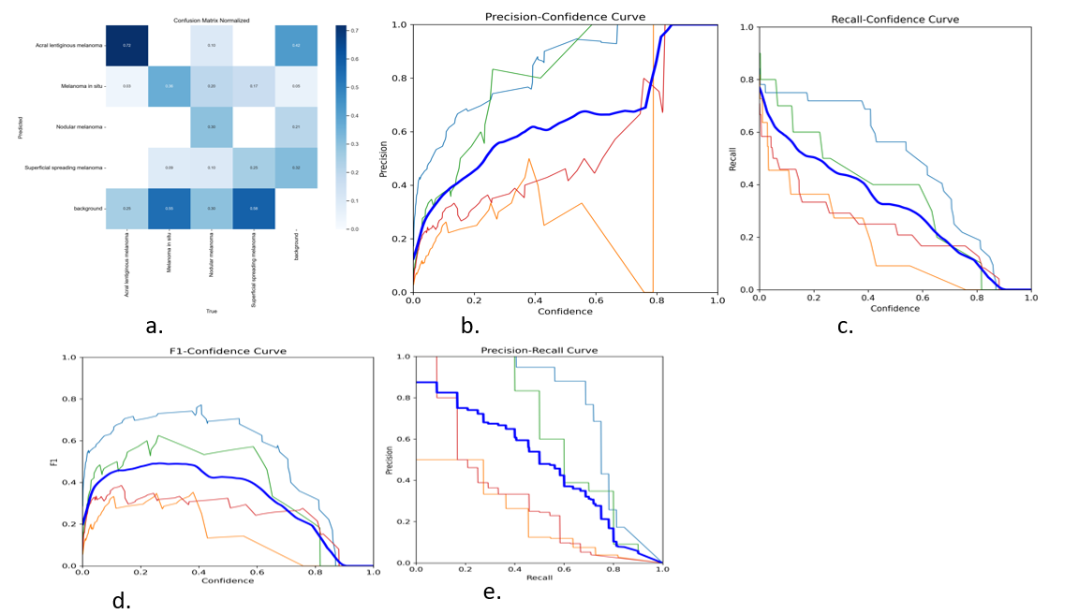
Fig. A. 4 YOLOv5 SAVE results from a. confusion matrix, b. precision, c. recall, d. F1-confidence, e. precision-confidence

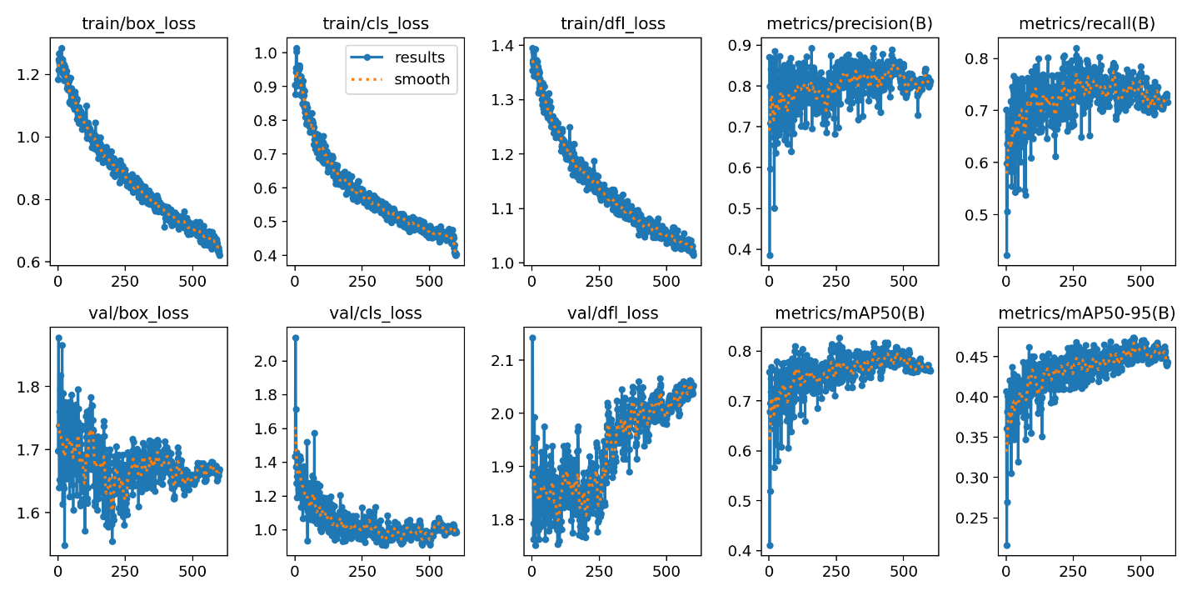
Fig. A. 5 YOLOv8 Convergence of loss functions for a training set of WLI images and precision, recall, and average precision
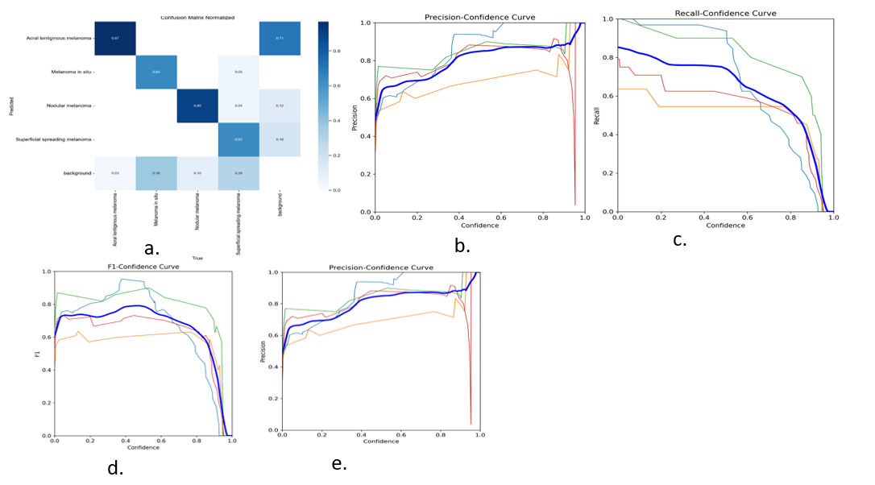
Fig. A. 6 YOLOv8 WLI results from a. confusion matrix, b. precision, c. recall, d. F1-confidence, e. precision-confidence
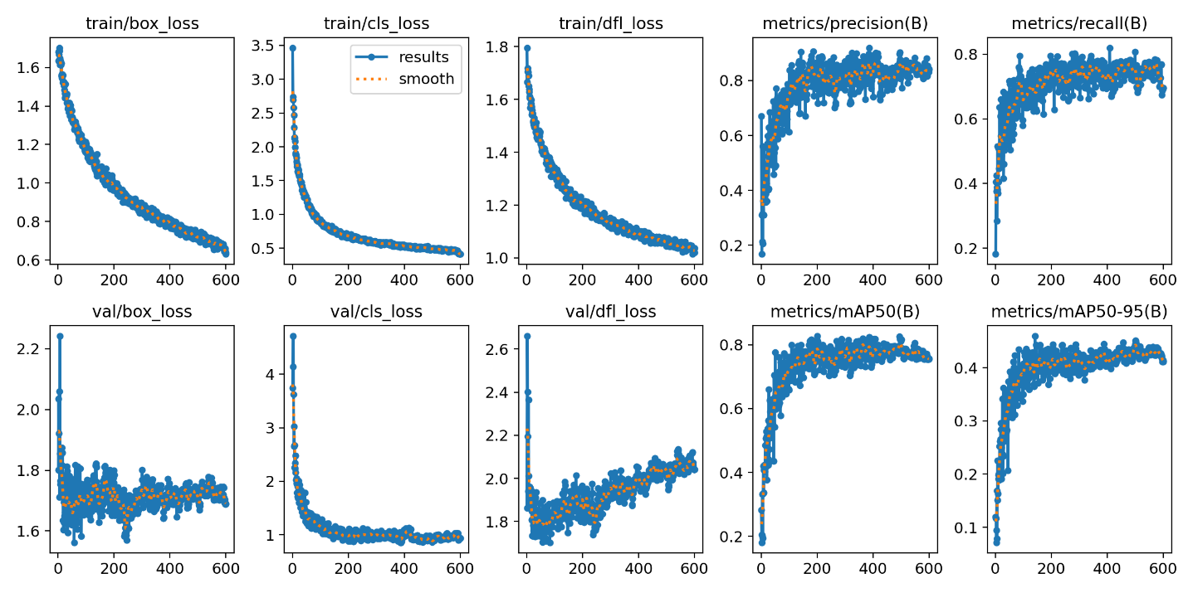
Fig. A. 7 YOLOv8 Convergence of loss functions for a training set of SAVE images and precision, recall, and average precision
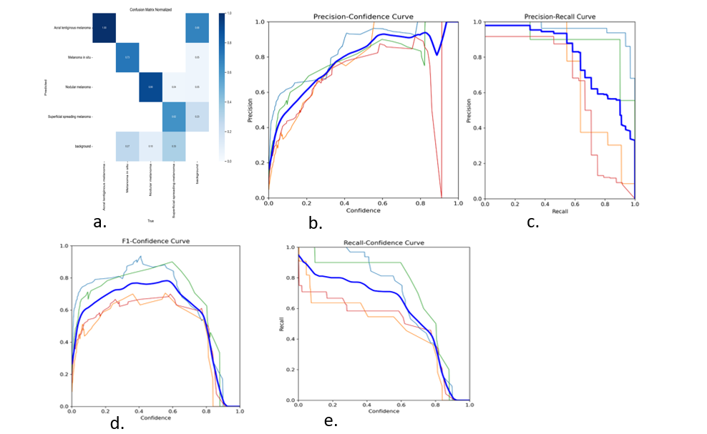
Fig. A. 8 YOLOv8 SAVE results from a. confusion matrix, b. precision, c. recall, d. F1-confidence, e. precision-confidence
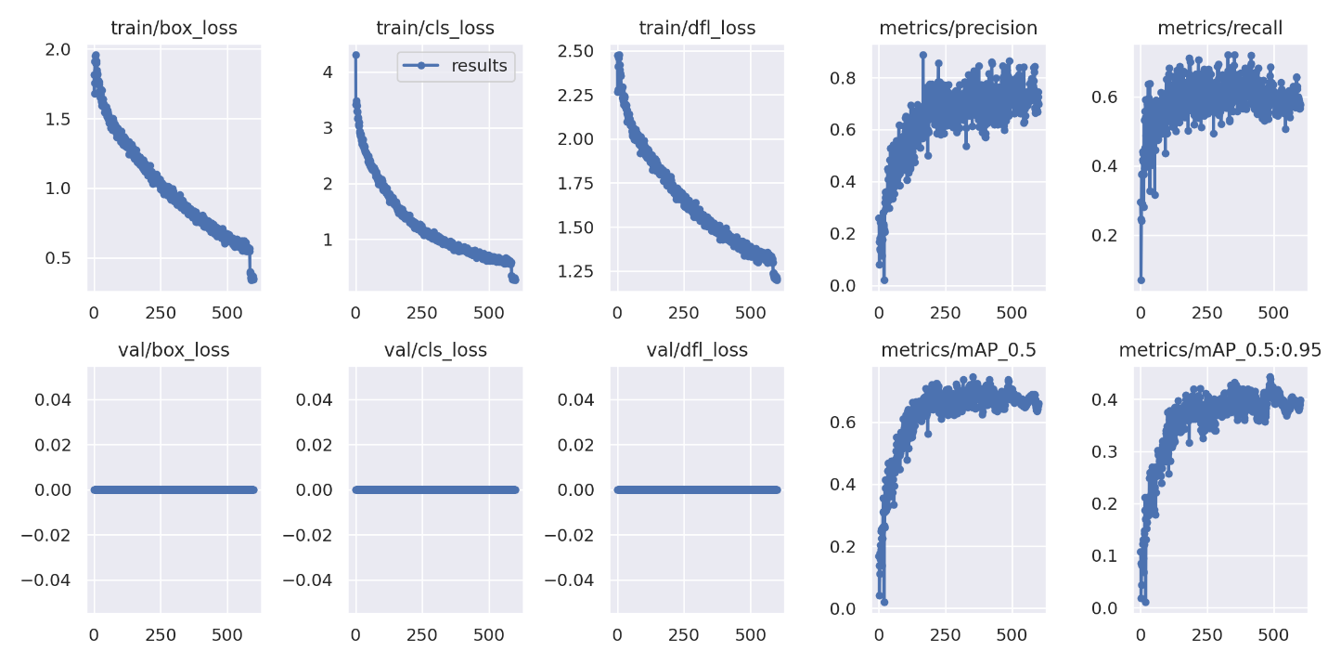
Fig. A. 9 YOLOv9 Convergence of loss functions for a training set of WLI images and precision, recall, and average precision
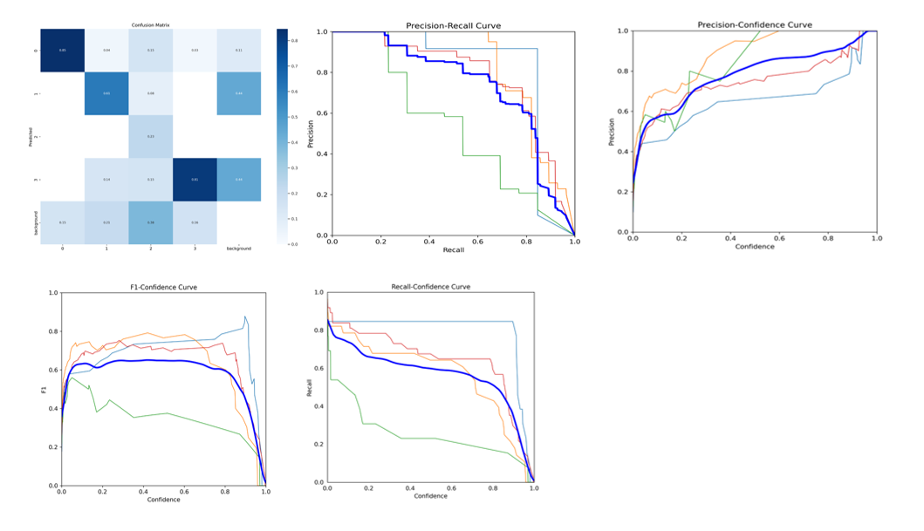
Fig. A. 10 YOLOv9 WLI results from a. confusion matrix, b. precision, c. recall, d. F1-confidence, e. precision-confidence

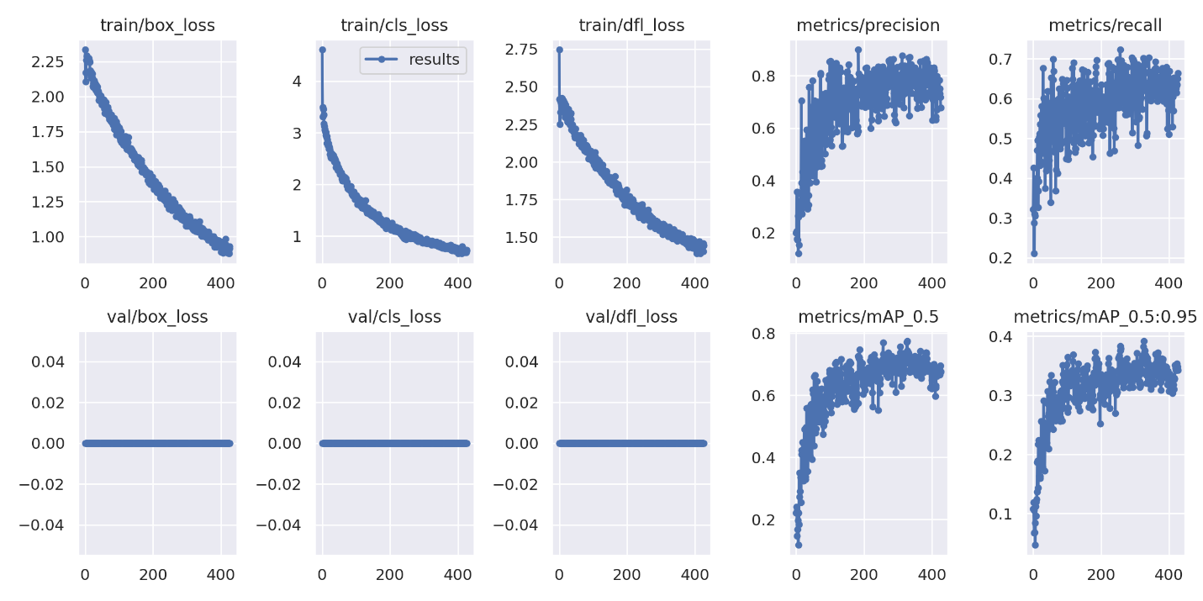
Fig. A. 11 YOLOv9 Convergence of loss functions for a training set of SAVE images and precision, recall, and average precision

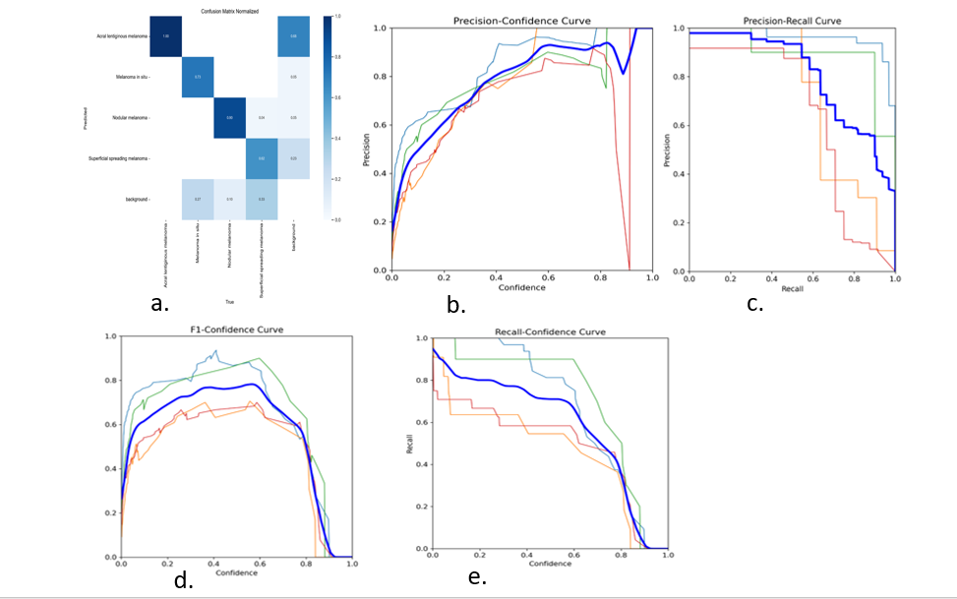
Fig. A. 12 YOLOv9 SAVE results from a. confusion matrix, b. precision, c. precision-recall, d. F1-confidence, e. recall-confidence
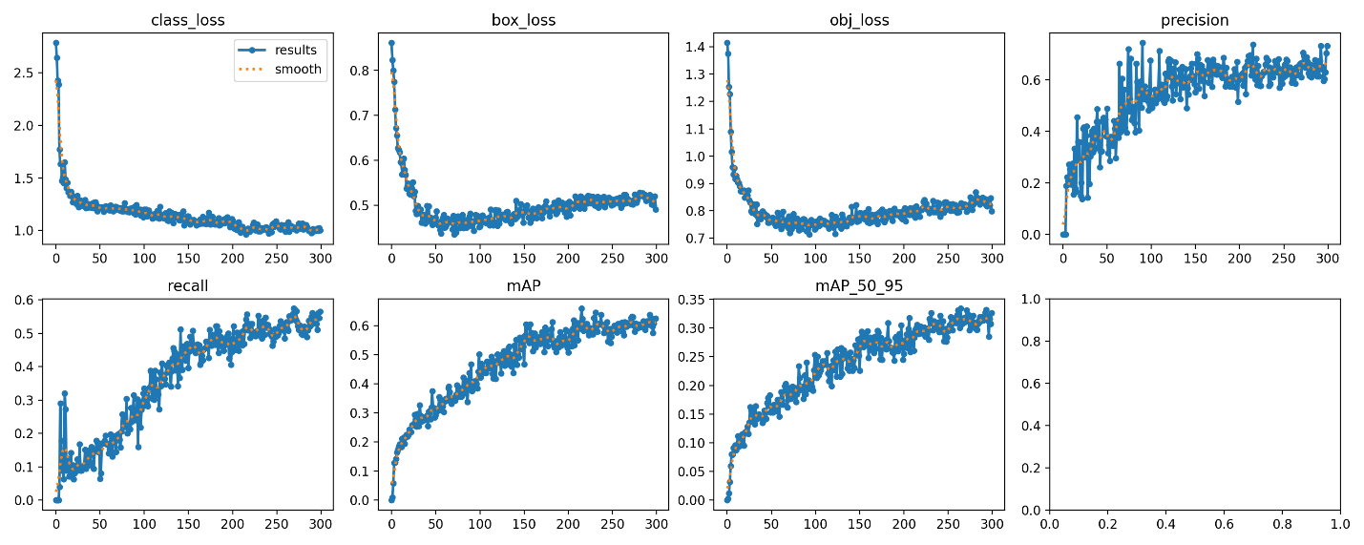
Fig. A. 13 YOLO-NAS Convergence of loss functions for a training set of WLI images and precision, recall, and average precision
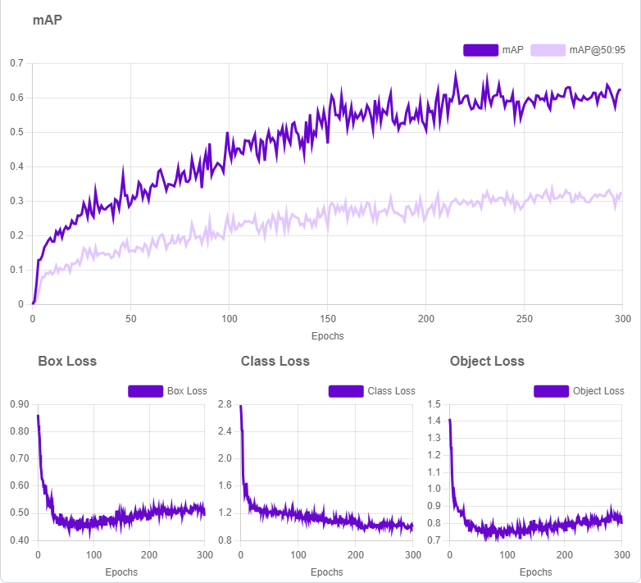
Fig. A. 14 YOLO-NAS WLI training results of mAP, Box loss, Class loss, and Object loss

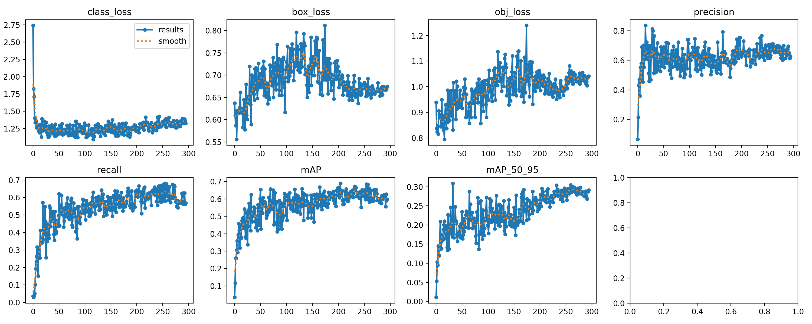
Fig. A. 15 YOLO-NAS Convergence of loss functions for a training set of SAVE images and precision, recall, and average precision
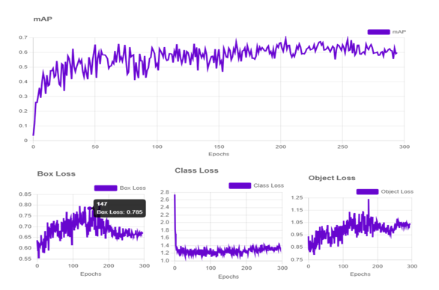
Fig. A. 16 YOLO-NAS SAVE training results of mAP, Box loss, Class loss, and Object loss

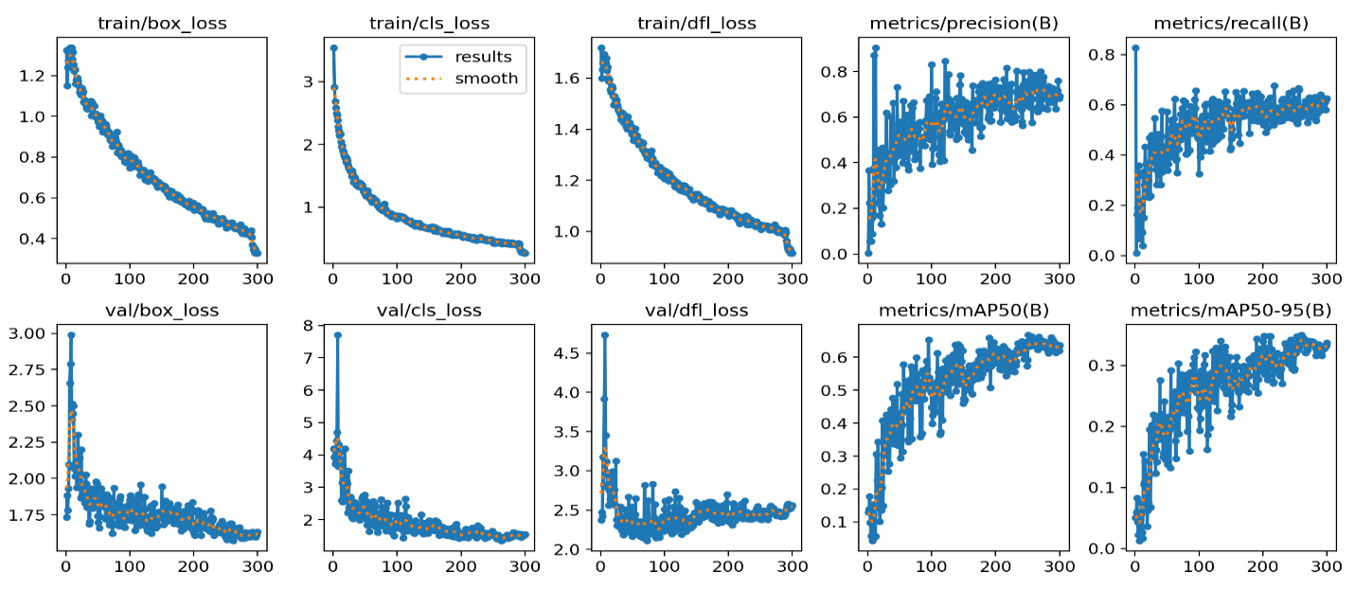
Fig. A. 17 Roboflow 3.0 convergence of loss functions for a training set of WLI images and precision, recall, and average precision
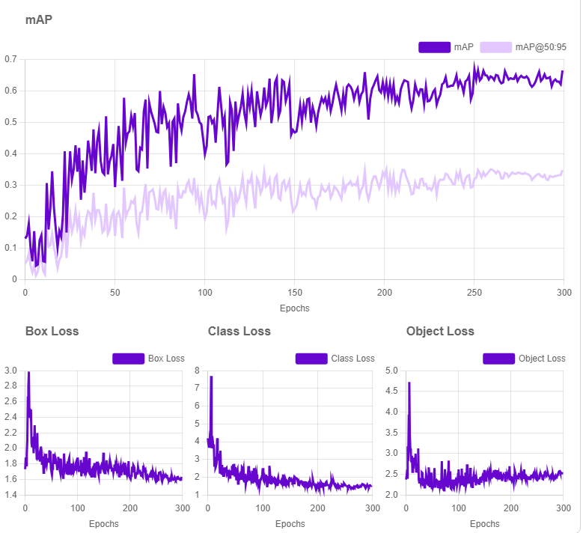
Fig. A. 18 Roboflow 3.0 WLI training results of mAP, Box loss, Class loss, and Object loss
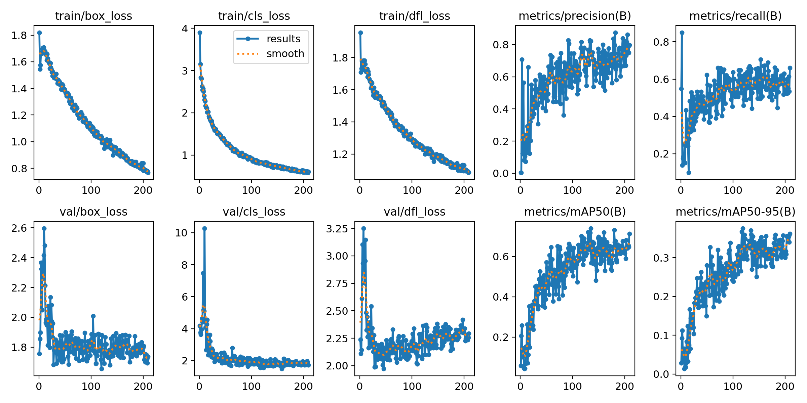
Fig. A. 19 Roboflow 3.0 convergence of loss functions for a training set of SAVE images and precision, recall, and average precision
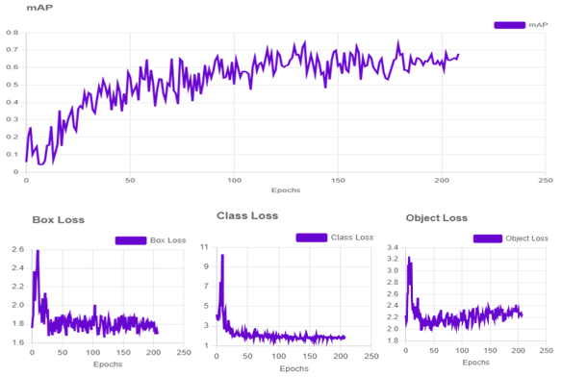
Fig. A. 20 Roboflow 3.0 SAVE training results of mAP, Box loss, Class loss, and Object loss

APPENDIX B

VITA

(END OF THE DOCUMENT)

